Blue(3): The Rock Pile

AC Control Switch

System Verification Documentation

Wiley Braun
Zack Pelster
Andrew Victor

June 6th, 2019

Table of Contents
Table of Contents 1
System Requirements 2
Additional Requirements 2
Block Diagram 3
Interface Definitions 4
Enclosure 6
Arduino Code 7
Application Code 13
Application Layout 14
Schematics & PCB 15
Dimmer 15
Converter 16
USB Charger 17
Bill of Materials 18

System Requirements
- Customer Requirement: The switch needs to work for household lights.
Engineering Requirement: The system will turn off and on at least 2 independent household lamps with up to 100W incandescent bulbs and report current watts delivered by each channel.
- Customer Requirement: The system needs to have a simple application
Engineering Requirement: 9 out of 10 users will be able to turn the switches off and on from a mobile phone in less than 10 seconds without any training or having previously seen the interface.
- Customer Requirement: The system must be safe.
Engineering Requirement: The system will use only US standard plugins for connecting to external devices and will not allow any object with a diameter greater than 1mm to enter the enclosure, and will be disable if more than 5A is drawn from the wall power.
- Customer Requirement: The system must have a timer
Engineering Requirement: The system must turn off the output after a time of upto 1 hour ± 1 minute when enabled.
- Customer Requirement: The system must be wireless
Engineering Requirement: The system will be able to accept commands from a mobile phone over 20 feet away from the plugins.

Additional Requirements
Customer Requirement: The system must include a USB port to charge a device.
Engineering Requirement: The system must include a USB port that can supply 5V and 1A DC to a connected device, to charge that device.
Customer Requirement: The system must include a way to dim the lights through the app.
Engineering Requirement: The system must be able to dim each light independently, within a range of at least 100% to 50% or less brightness, using the app.

Block Diagram
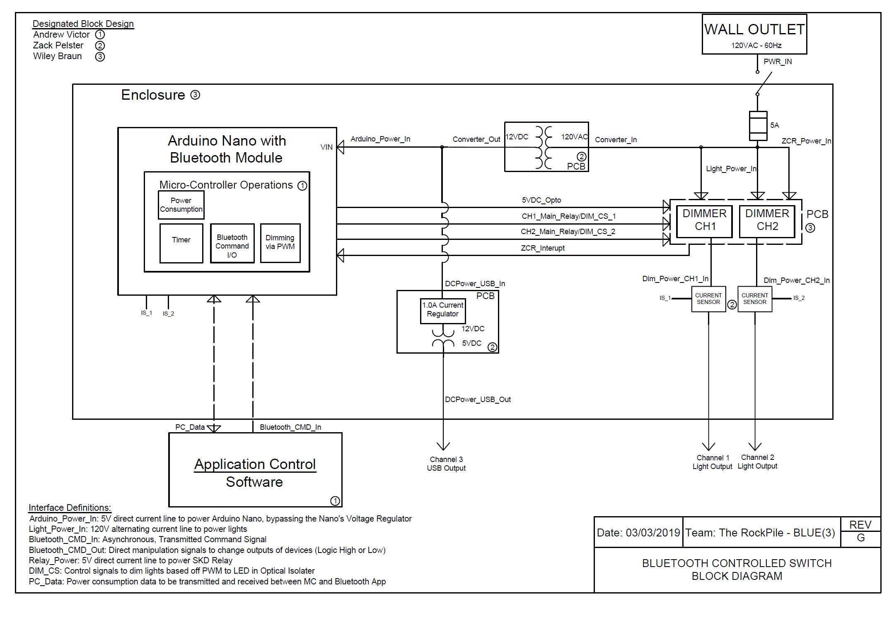

Interface Definitions
Interface | Description
PWR_IN | 120VAC at 60Hz supply power to entire system
Arduino_Power_In | 5V for powering Arduino
Relay_Power | 5V Power Supply from Nano to Relay Module
CH1_pin | Output high/low to channel 1 whether command should be on/off, respectively
CH2_pin | Output high/low to channel 2 whether command should be on/off, respectively
Zero_Cross_CH1 | Frequency based pulse train to dimmer channel 1 determined by input from app
Zero_Cross_CH2 | Frequency based pulse train to dimmer channel 2 determined by input from app
analog_CH1 | Current Sensing for channel 1 of output to produce power consumption data to app
analog_CH2 | Current Sensing for channel 2 of output to produce power consumption data to app
Bluetooth_CMD_In | Asynchronous (9600 BAUD) transmission to Bluetooth module of command inputs
Bluetooth_CMD_Out | 2 to 5 V output from Arduino Nano powering different parts of the Arduino
PC_Data | Power consumption data to be transmitted and received between Arduino and Bluetooth app
DCPower_USB_In | 12V input from the AC-DC Converter
DCPower_USB_Out | 5V at 1A outputted via the dual USB A port (1A when charging one device, 500mA each when charging two devices)
Light_Power_In | Following the fuse/switching block, this allows a maximum of 5A to the relay module for full supply amount
Converter_In | 120VAC input to be converted to DC output
Converter_Out | 12V DC output to Arduino and USB charger
Dim_Power_CH1_In | Supplying power to channel 1 on dimmer to be manipulated based DIM_CS1
Dim_Power_CH2_In | Supplying power to channel 2 on dimmer to be manipulated based DIM_CS2
ZCR_Power_In | Power tapped off Light_Power_In to read the zero cross reading of the 120VAC line to determine where DIM_CS1/DIM_CS2 pulses should line up to manipulate Dim_Power_CH1_In/Dim_Power_CH2_In, respectively.
ZCR_Power_Out | Direct output of of 2 to 5 volts from the Arduino to power the optical isolator for dimming purposes
CH1_Output_Dim_Out | Direct output of channel 1 once the dimming protocol has been asserted
CH2_Output_Dim_Out | Direct output of channel 2 once the dimming protocol has been asserted

Enclosure
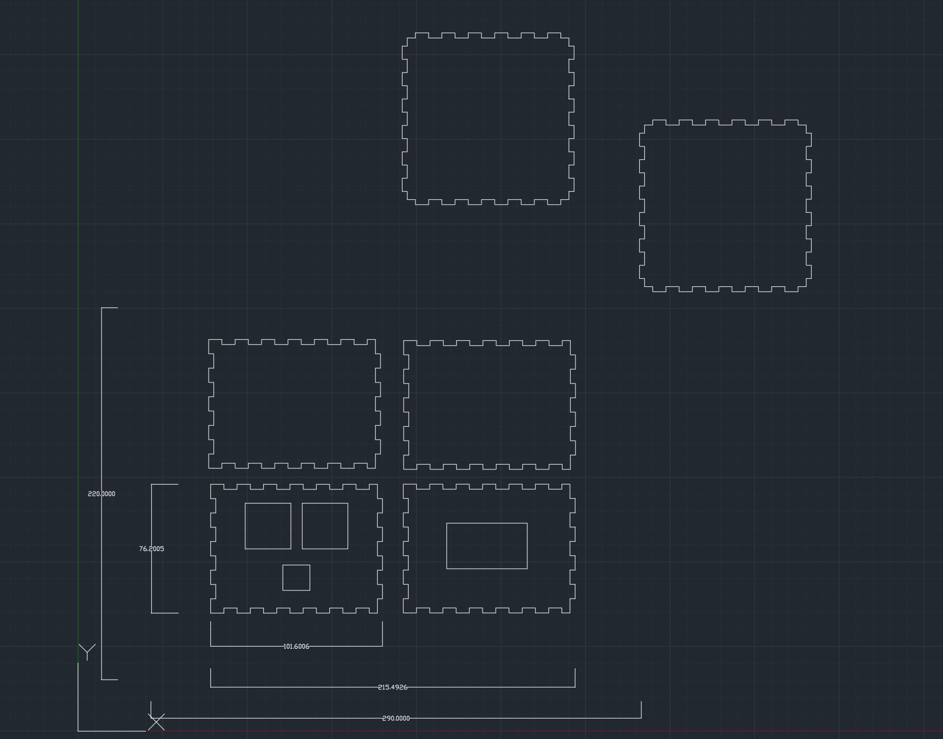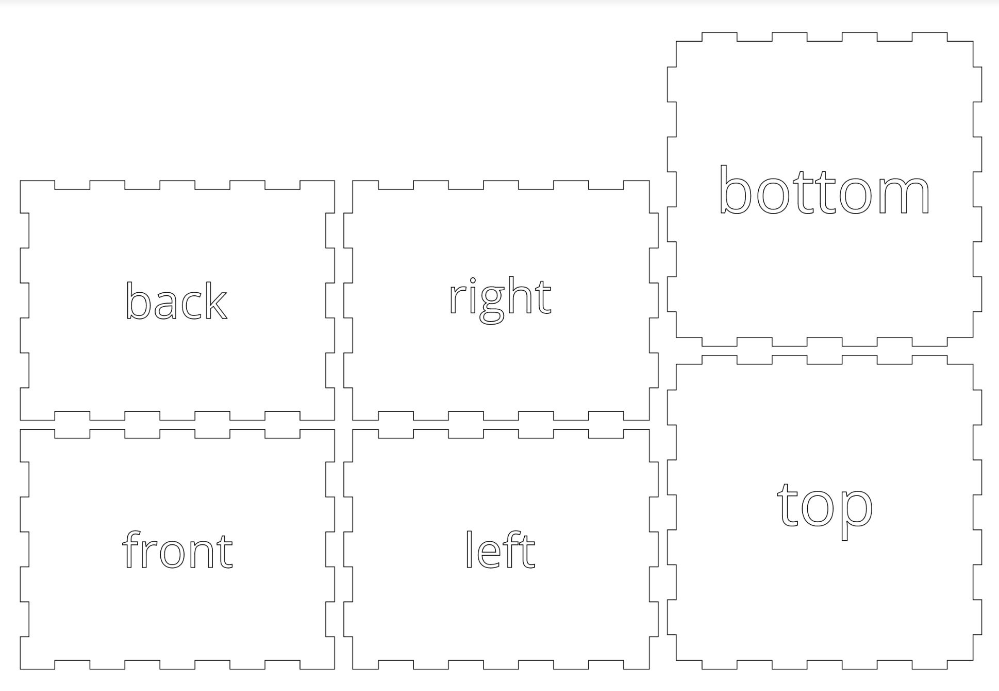

Arduino Code
//Global variable declaration for variables to be used later in the program
//int vinPin = VIN;
String inputString = ""; //String to be received via Bluetooth
char input; //Char to be sent back and forth for Bluetooth communication
const int CH1_pin = 5; //Pin for channel 1
const int CH2_pin = 6; //Pin for channel 2
const int CH1_analog = A0; //Pin for reading from channel 1
const int CH2_analog = A1; //Pin for reading from channel 2
const int opticalPin = 9; //Pin for the optical isolator
float power1; //Variable to represent power (watts) for channel 1
float power2; //Variable to represent power (watts) for channel 2
long lastSample1 = 0; //Last sample value used for calculating channel 1 power
long sampleSum1 = 0; //Sample sum used for calculating channel 1 power
int sampleCount1 = 0; //Sample count used for calculating channel 1 power
long lastSample2 = 0; //Last sample value used for calculating channel 2 power
long sampleSum2 = 0; //Sample sum used for calculating channel 2 power
int sampleCount2 = 0; //Sample count used for calculating channel 2 power
int dimming = 64; //Dimming level (0-128) 0 = DIMMING ON, 128 = DIMMING OFF
unsigned long currentTime = 0; //Variable used for the current time of the timer
unsigned long startTime = 0; //Variable used as the starting time for the timer
const long period = 3600000; //Value in miliseconds to represent one hour for the timer
boolean isDim1 = false; //Variable used for dimming
boolean isDim2 = false; //Variable used for dimming
char inputChar; //Variable used for input
int prevInput; //Variable used for previous input
int rawVal1; //Raw analog pin value for channel 1
int rawVal2; //Raw analog pin value for channel 2
float vpp = 4.8828125; //Value used for calculating power (millivolts per point (5/1024)*1000)

#include <TimerOne.h>
#include <SimpleDHT.h>
#include "Timer.h"
#include <SoftwareSerial.h>
SoftwareSerial BTserial(10, 11); //Enable pins 10 and 11 for Bluetooth
//Pin 10 is connected to the TXD Pin on the HC-05
//Pin 11 is connected to the RXD Pin on the HC-05

//Function used to calculate the zero-crossing of channel 1 for dimming
void zero_cross1_int() {

int dimtime = 65*dimming; //Amount of time to dim for a 60Hz load
delayMicroseconds(dimtime); //Wait until firing the TRIAC
digitalWrite(CH1_pin, HIGH); //Fire the TRIAC
delayMicroseconds(8.33); //Delay used for TRIAC propagation delay at 60Hz load
digitalWrite(CH1_pin, LOW);

}

//Function used to calculate the zero-crossing of channel 2 for dimming
void zero_cross2_int() {

int dimtime = 65*dimming; //Amount of time to dim a 60Hz load
delayMicroseconds(dimtime); //Wait until firing the TRIAC
digitalWrite(CH2_pin, HIGH); //Fire the TRIAC
delayMicroseconds(8.33); //Delay used for TRIAC propagation delay at 60Hz load
digitalWrite(CH2_pin, LOW);

}

void setup() {

Serial.begin(9600); //Standard BAUD communication rate
pinMode(CH1_pin, OUTPUT); //Set Pin 11 as an output pin
pinMode(CH2_pin, OUTPUT); //Set Pin 9 as an output pin
pinMode(opticalPin, OUTPUT);
pinMode(CH1_analog, INPUT);
pinMode(CH2_analog, INPUT);
//pinMode(VIN, input);
BTserial.begin(9600); //Standard Bluetooth communication rate
startTime = millis();
attachInterrupt(0, zero_cross1_int, RISING); //Interrupt for channel 1
attachInterrupt(0, zero_cross2_int, RISING); //Interrupt for channel 2
detachInterrupt(digitalPinToInterrupt(2));

}
/*
The following code represents the communication between the Arduino, HC=05 Bluetooth Module, and Android Application
The following loop will act as a "menu" where different inputs will be sent from the app
Based on what the input is, the Arduino code will respond with the necessary outputs to system
There will be a constantly running while loop where the HC-05 will look for the next input
There will be a timer implemented for safety purposes that will shut the system off after an hour of uninterrupted activity

*/

void loop() {

//digitalWrite(CH1_pin, LOW);
//digitalWrite(CH2_pin, LOW);

//Calculate the current time of the program
currentTime = millis();

//TIMER
//Check the current time of the program and compare it to the starting time of the program
//If over an hour has passed, turn off both channels (for safety) and reset the start time
if(currentTime - startTime >= period) {
digitalWrite(CH1_pin, LOW);
digitalWrite(CH2_pin, LOW);
startTime = currentTime;
}

//Following if statements are used for calculating the current watts delivered by channel 1
if(millis() > lastSample1 + 1) {
sampleSum1 += sq((analogRead(CH1_analog) - 512)); //square the sample sum
sampleCount1++; //increment the count variable
lastSample1 = millis(); //reset the timer for lastSample1
}

//Calculate values once the sampleCount equals 1000
if(sampleCount1 == 1000) {
//Averageing values
float average1 = (sampleSum1/sampleCount1); //Average value of sum per 1000 counts
float sqRtAverage1 = sqrt(average1); //RMS calculation
float voltage1 = (sqRtAverage1 * vpp); //Final voltage in mV
float amperage1 = (voltage1/66); //Device paramater to obtain amps from mV
power1 = amperage1*120; //Multiply amps by 120V load to get power (watts)
Serial.println("Wattage: " + String(power1)); //Divide voltage by 66 to get Amps (device parameter)
sampleSum1 = 0;
sampleCount1 = 0;
BTserial.println(power1);
}

//Following if statements are used for calculating the current watts delivered by channel 2
if(millis() > lastSample2 + 1) {
sampleSum2 += sq((analogRead(CH2_analog) - 512)); //square the sample sum
sampleCount2++;
lastSample2 = millis();
}

//Calculate values once the sampleCount equals 1000
if(sampleCount2 == 1000) {
//Averageing values
float average2 = (sampleSum1/sampleCount1); //Average value of sum per 1000 counts
float sqRtAverage2 = sqrt(average2); //RMS calculation
float voltage2 = (sqRtAverage2 * vpp); //Final voltage in mV
float amperage2 = (voltage2/66); //Device paramater to obtain amps from mV
power2 = amperage2*120; //Multiply amps by 120V load to get power (watts)
Serial.println("Wattage: " + String(power2)); //Divide voltage by 66 to get Amps (device parameter)
sampleSum2 = 0;
sampleCount2 = 0;
//BTserial.println(power2);
}

//BLUETOOTH COMMUNICATION
//While BT communication is available, read the input and add it to the input string
if(BTserial.available()) {
while(BTserial.available()) {
inputChar = (char)BTserial.read(); //Read the input character sent by the HC-05
inputString += inputChar; //Add the input char to the input string
}

if(inputString == "4" || inputString == "6") {

prevInput = inputString.toInt();
if(prevInput == 4) {
isDim1 = true;
digitalWrite(CH1_pin, HIGH);
digitalWrite(opticalPin, HIGH);
dimming=64;
attachInterrupt(0, zero_cross1_int, RISING); //Interrupt for channel 1
//BTserial.println(power1);
//BTserial.println(" | ");
}

else if(prevInput == 6) {
isDim2 = true;
digitalWrite(CH2_pin, HIGH);
digitalWrite(opticalPin, HIGH);
dimming = 64;
attachInterrupt(0, zero_cross2_int, RISING);
}

/*else if(prevInput == 6 && isDim1 == true) {
isDim2 = true;
digitalWrite(CH2_pin, HIGH);
digitalWrite(opticalPin, HIGH);
dimming = 64;
attachInterrupt(0, zero_cross1_int, HIGH);
attachInterrupt(0, zero_cross2_int, HIGH);
}*/

}

//Clearing the serial buffer for the next input
while(BTserial.available() > 0) {
input = BTserial.read(); //Clear the serial buffer
}

//If the program receives a "1" from the application, turn ON channel 1
if(inputString == "1") {
digitalWrite(CH1_pin, HIGH);
// BTserial.println(power1);
}

//If the program receives a "0" from the application, turn OFF channel 1
else if(inputString == "0") {
detachInterrupt(digitalPinToInterrupt(2));
digitalWrite(CH1_pin, LOW); //Turn channel 1 OFF if a 0 is received
//BTserial.println(power1);
}

//If the program receives a "2" from the application, turn ON channel 2
else if(inputString == "2") {
digitalWrite(CH2_pin, HIGH); //Turn channel 2 ON if a 2 is received
}

//If the program receives a "3" from the application, turn OFF channel 2
else if(inputString == "3") {
//detachInterrupt(digitalPinToInterrupt(2));
digitalWrite(CH2_pin, LOW); //Turn channel 2 OFF is a 3 is received
}

inputString = ""; //Clear the input string
}

}

Application Blocks
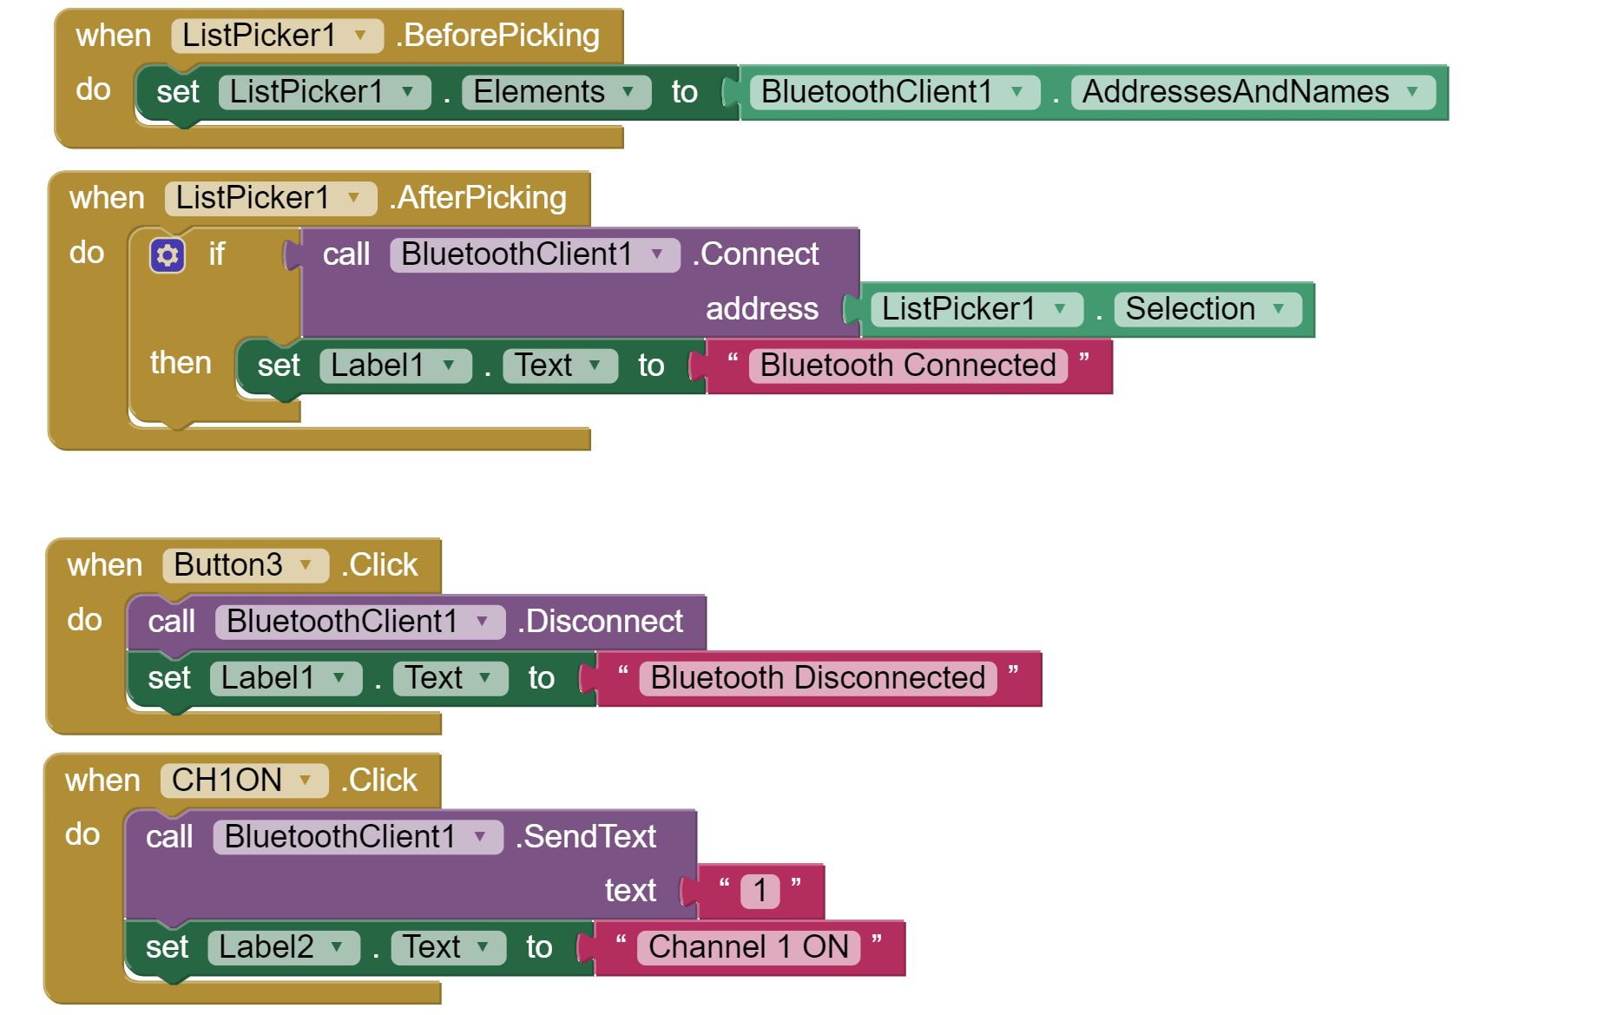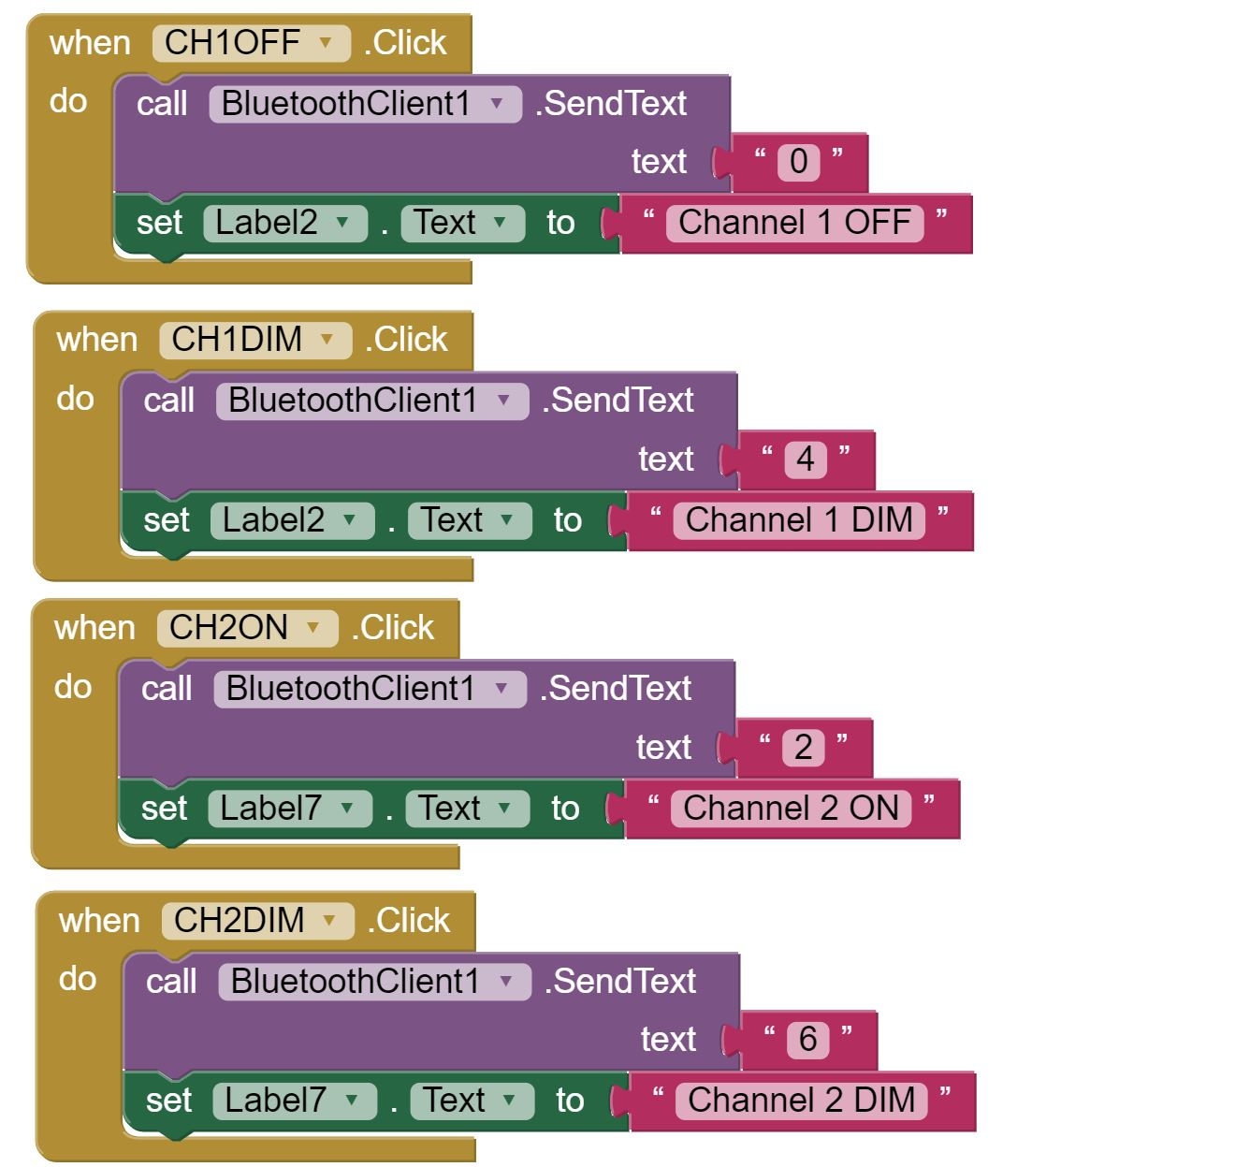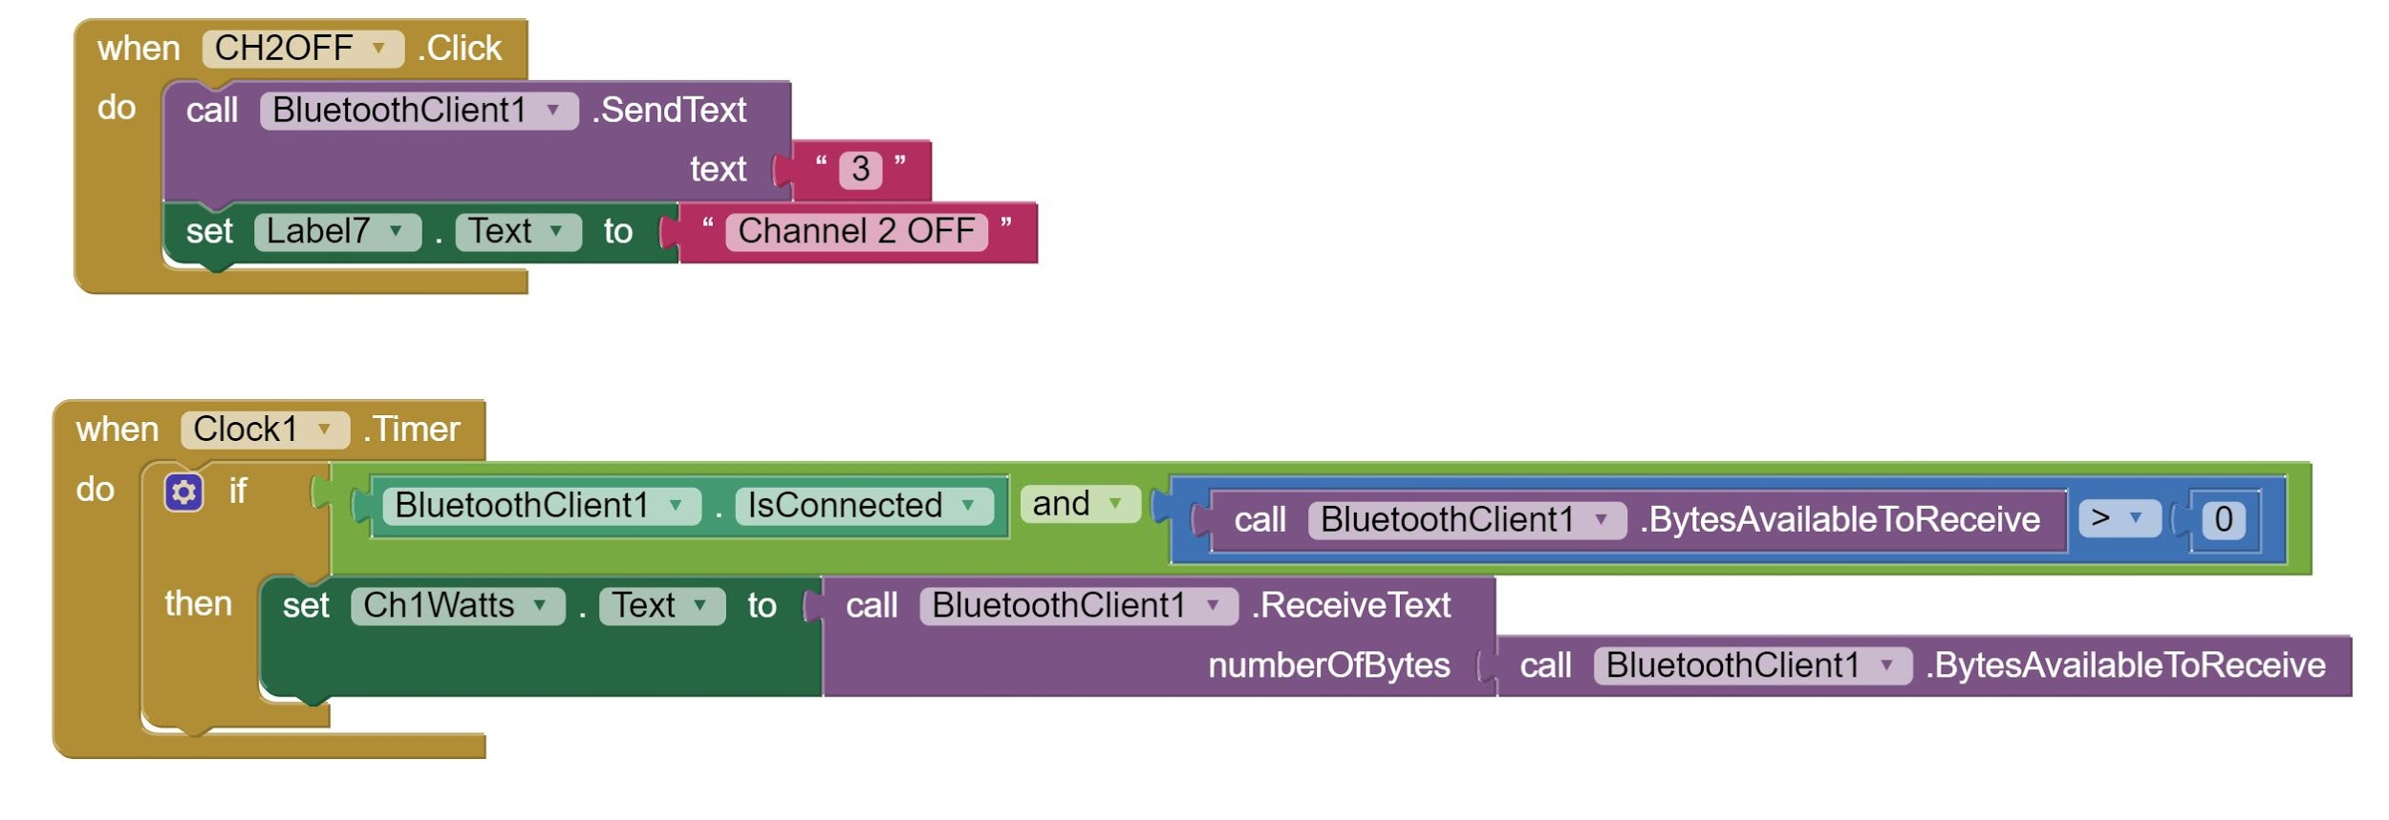

Application Interface

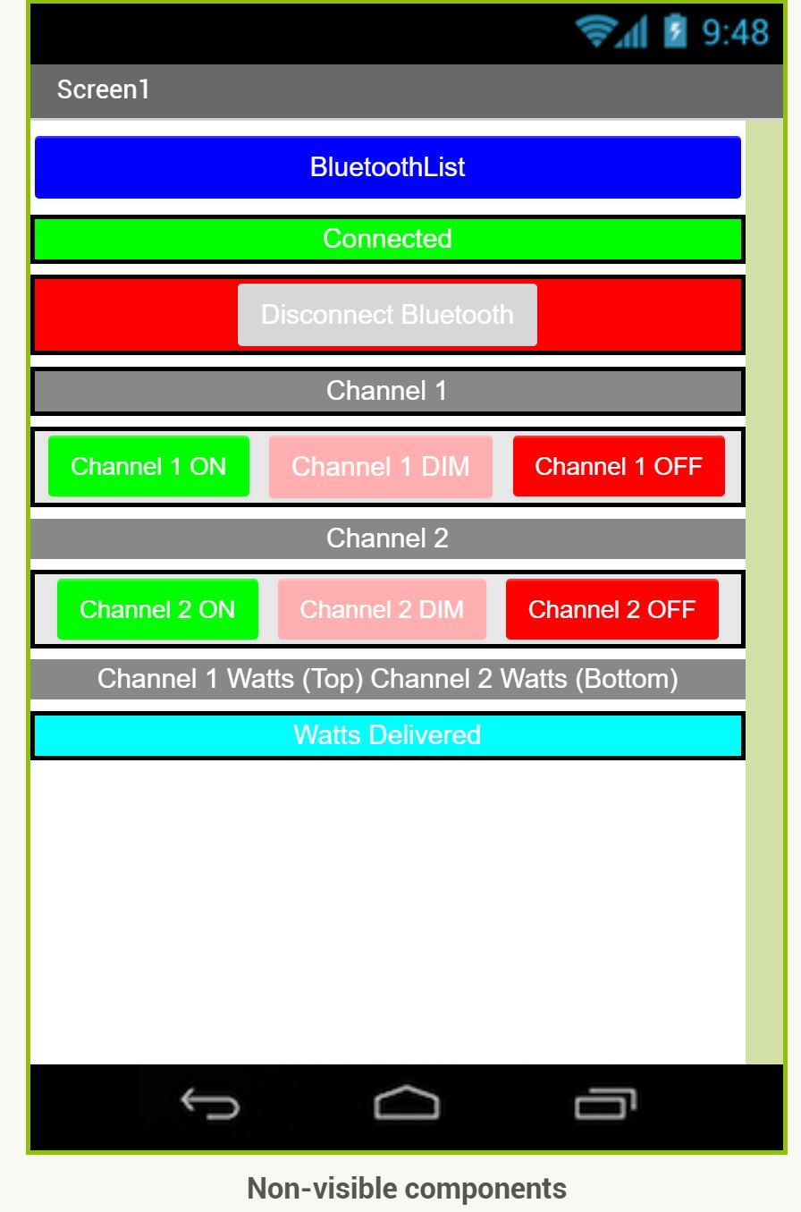

Schematics & PCB

Dimmer
Schematic

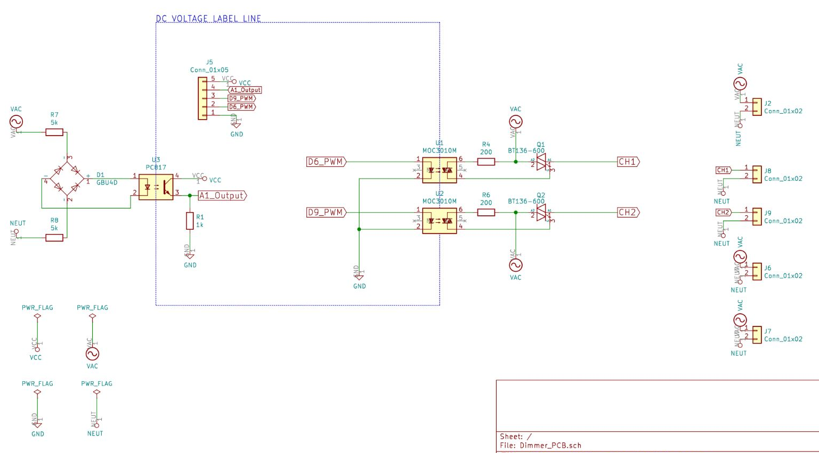
PCB
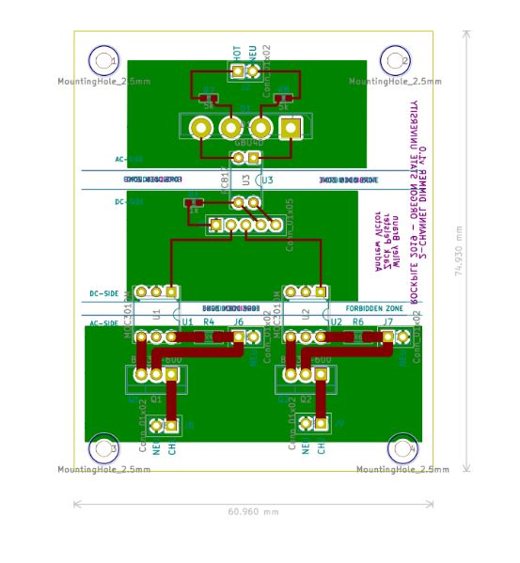

Converter
Schematic
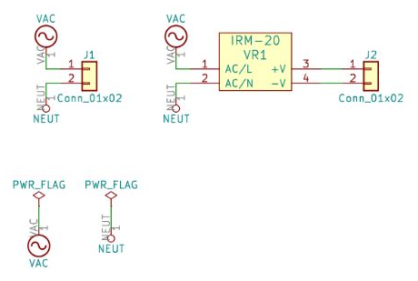
PCB
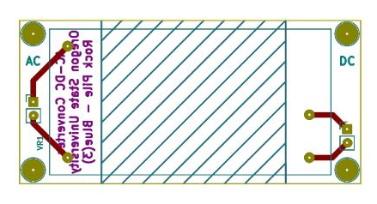

USB Charger
Schematic
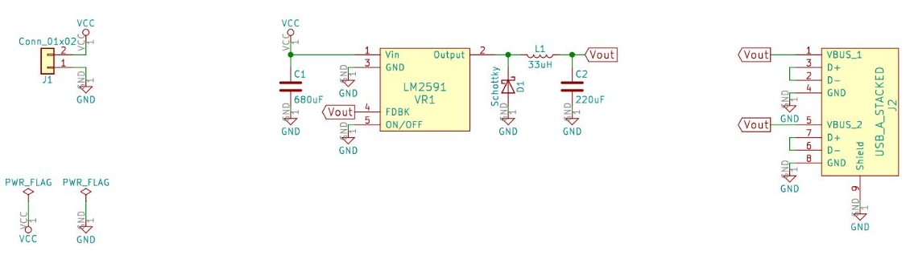
PCB

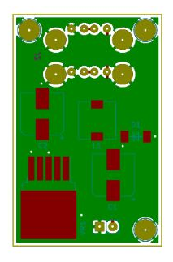

Bill of Materials
Part | Link | Cost per unit | Units
AC to DC Step Down Converter (5V-output) | https://www.digikey.com/product-detail/en/recom-power/RAC04-05SC-W/945-2210-ND/4976892 |  | 1
AC to DC Step Down Converter (12V-output) | https://www.digikey.com/product-detail/en/recom-power/RAC10-12DK-277/945-3125-5-ND/7807873 | $11.40 | 1
AWG Power Socket with 5A Fuse and Switch | https://www.amazon.com/URBEST-Socket-Module-Switch-Terminals/dp/B06XNMT3WL/ref=pd_sim_23_3/143-6602060-0462952?_encoding=UTF8&pd_rd_i=B06XNMT3WL&pd_rd_r=39a8c526-437f-11e9-870e-afb0e07225f8&pd_rd_w=tD7OQ&pd_rd_wg=RJcdE&pf_rd_p=90485860-83e9-4fd9-b838-b28a9b7fda30&pf_rd_r=0F556JDR9ZH2KZTYSPXB&psc=1&refRID=0F556JDR9ZH2KZTYSPXB | $7.99 | 1
5x20mm, Time-Lagging 250VAC 5A Fuse | https://www.digikey.com/product-detail/en/littelfuse-inc/0218005.MXP/F1748-ND/777604 |  | 1
Bluetooth Module | http://eecs.oregonstate.edu/tekbots/modules/hc-05/ | $6 | 1
2 Channel Relay | http://eecs.oregonstate.edu/tekbots/modules/2chrelay | $4 | 1
Satco 80-1142 3 Wire 2 Pole Snap-In Convenience Outlet | https://www.globalindustrial.com/p/electrical/lighting-indoor/fixture-parts/3-wire-2-pole-snap-in-convenience-outlet?infoParam.campaignId=T9F&gclid=Cj0KCQjws5HlBRDIARIsAOomqA1qivxvYDrp3rqoo4BCdYFsXxXxFN1wxsyvRrFTEPMy_SakokaUrwIaAnBoEALw_wcB | $1.34 | 2
Wall outlet cord | https://www.cableleader.com/1ft-16-awg-universal-power-cord-iec320-c13-to-nema-5-15p.html?gclid=Cj0KCQjws5HlBRDIARIsAOomqA2EJS04pXv_MWzYdLCVtnVSNEZuJjROGQeERSrsQMOWNaKy2wfwWe8aAj_XEALw_wcB | $1.03 | 1
CONNECTOR; RECEPTACLE; USB; A SERIES; 1PORT; VERTICAL | https://www.alliedelec.com/product/te-connectivity/1734366-1/70085897/ | $0.71 | 2
ACS712 30A Hall Effect Current Sensor Module | https://secure.touchnet.net/C20159_ustores/web/classic/product_detail.jsp?PRODUCTID=1924 | $7 | 2
AC/DC CONVERTER 12V 22W | https://www.digikey.com/product-detail/en/mean-well-usa-inc/IRM-20-12/1866-3038-ND/7704663 | $11.18 | 1
IC REG BUCK 5V 1A TO263-5 | https://www.digikey.com/products/en?mpart=LM2591HVS-5.0/NOPB&v=296 | $6.36 | 1
Screw Terminal Block (Pitch 2.54) | https://www.digikey.com/product-detail/en/te-connectivity-amp-connectors/282834-2/A98333-ND/1150135 | $0.88 | 7
Schottky Diode | https://www.digikey.com/product-detail/en/rohm-semiconductor/RB081LAM-20TR/RB081LAM-20TRCT-ND/7793358 | $0.40 | 1
USB-A | https://www.digikey.com/product-detail/en/on-shore-technology-inc/USB-A2VSW6/ED2984-ND/2677745 | $1.29 | 1
LM2591 | https://www.digikey.com/products/en?mpart=LM2591HVS-5.0/NOPB&v=296 | $6.36 | 1
Unpolarized capacitor 1 | https://www.digikey.com/product-detail/en/panasonic-electronic-components/EEE-FK1A681P/PCE3781CT-ND/766157 | $0.75 | 1
Unpolarized capacitor 2 | https://www.digikey.com/product-detail/en/nichicon/UWX1A221MCL1GB/493-2098-1-ND/590073 | $0.35 | 1
Inductor | https://www.digikey.com/product-detail/en/epcos-tdk/B82472G6333M000/495-5679-1-ND/4245761 | $1.31 | 1
AC/DC CONVERTER 12V 22W | https://www.digikey.com/product-detail/en/mean-well-usa-inc/IRM-20-12/1866-3038-ND/7704663 | $11.48 | 1
Terminal Block, single row, 01x02, pitch 2.54 | https://www.digikey.com/product-detail/en/te-connectivity-amp-connectors/282834-2/A98333-ND/1150135 | $0.88 | 1

