HW09: Individual Assignment (110pts)
Replace all the highlighted placeholder text, below. You may change the style of this template, but please provide all the responses requested and keep the same sections / order.

Questions? Ask on Piazza or send me an email.

What is your name?
Yang Zhang

Which team are you on?
The insiders

Were you the Sprint 3 Scrum Master?
No

Are you the Sprint 4 Scrum Master?
No

Sprint 3 Contributions (70pts)
Which user stories did you work on during the last Sprint and what is their status? You are required to help complete (with your pair programming partner) 2 user stories per Sprint except when you are the Scrum Master.
Identifier | User Story | Status
US-004-2 | Get talk: As a user I want to post my own ideas and questions into the talk board (add post function and save data into set up database) | Done
US-004-4 | Get talk : As a User I want to go to the forum page and see a beautiful board page (create forum page basic skeleton and styling the page) | Done

User Story 1 (30pts)
What is one of the user stories you worked on during the Sprint?
Get talk: As a user I want to post my own ideas and questions into the talk board (add post function and save data into set up database)

What is the status of the user story?
Done

Provide evidence (e.g., screenshots, URLs, etc.) showing your contributions to the completion of the first user story you worked on during the Sprint. If your grader is not convinced, you will lose points.
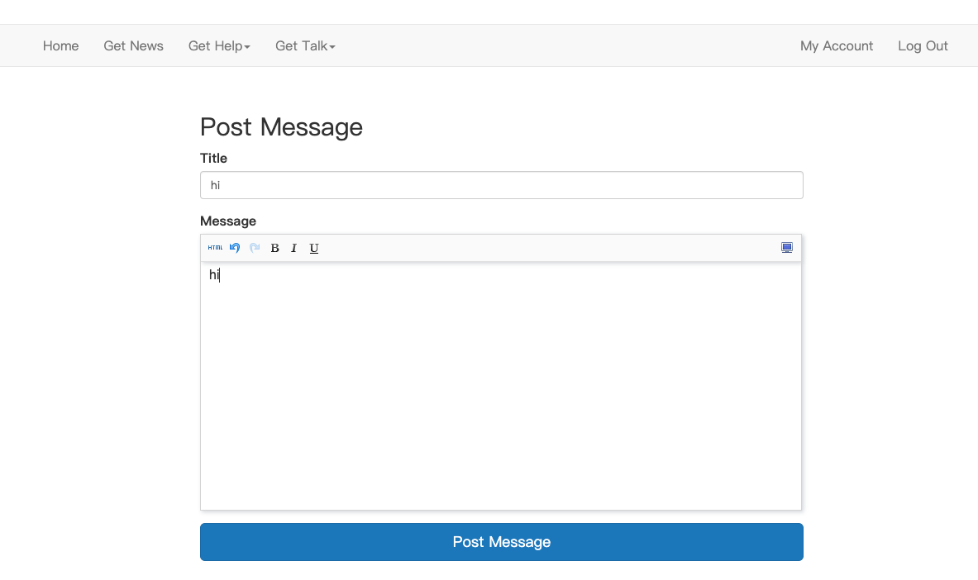
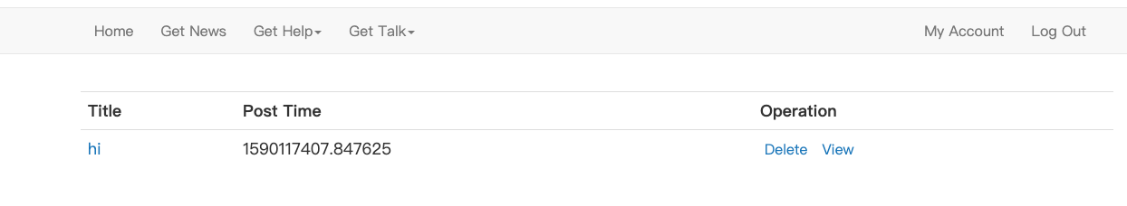
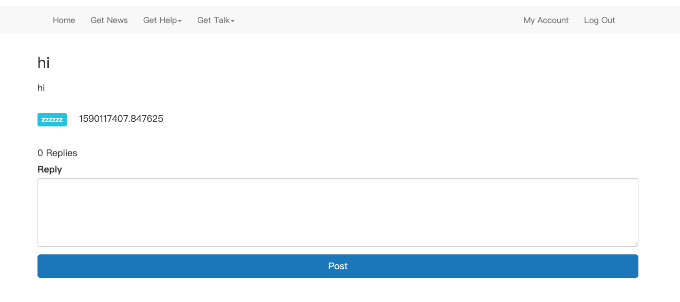
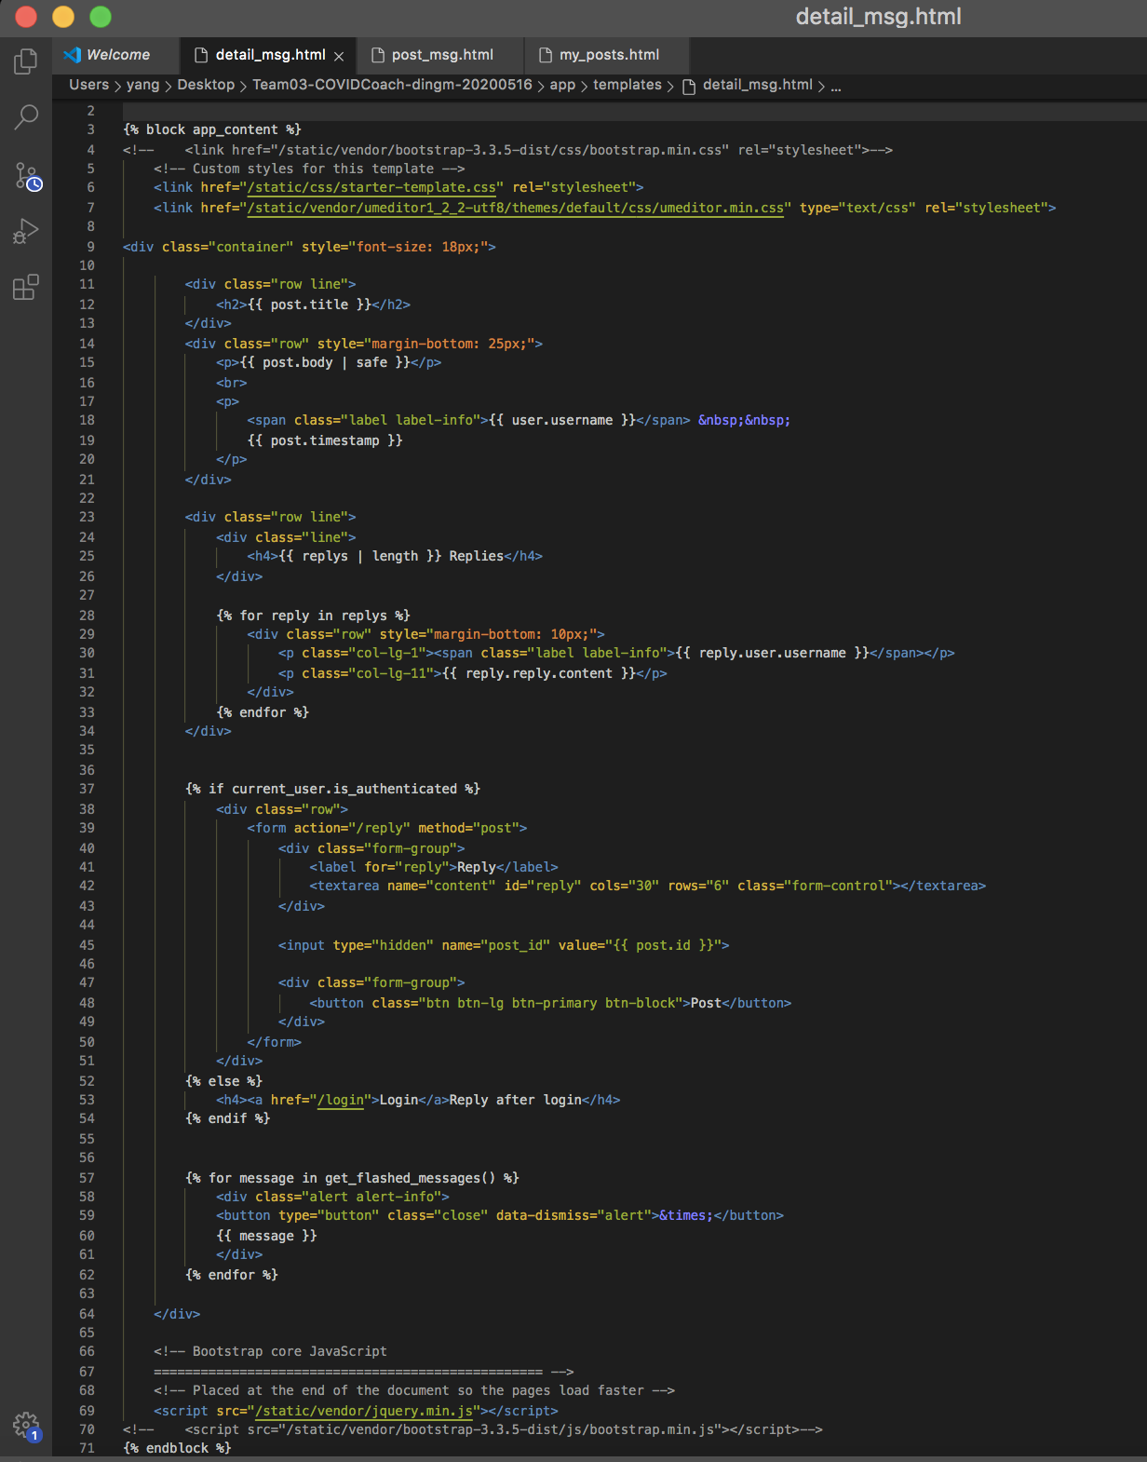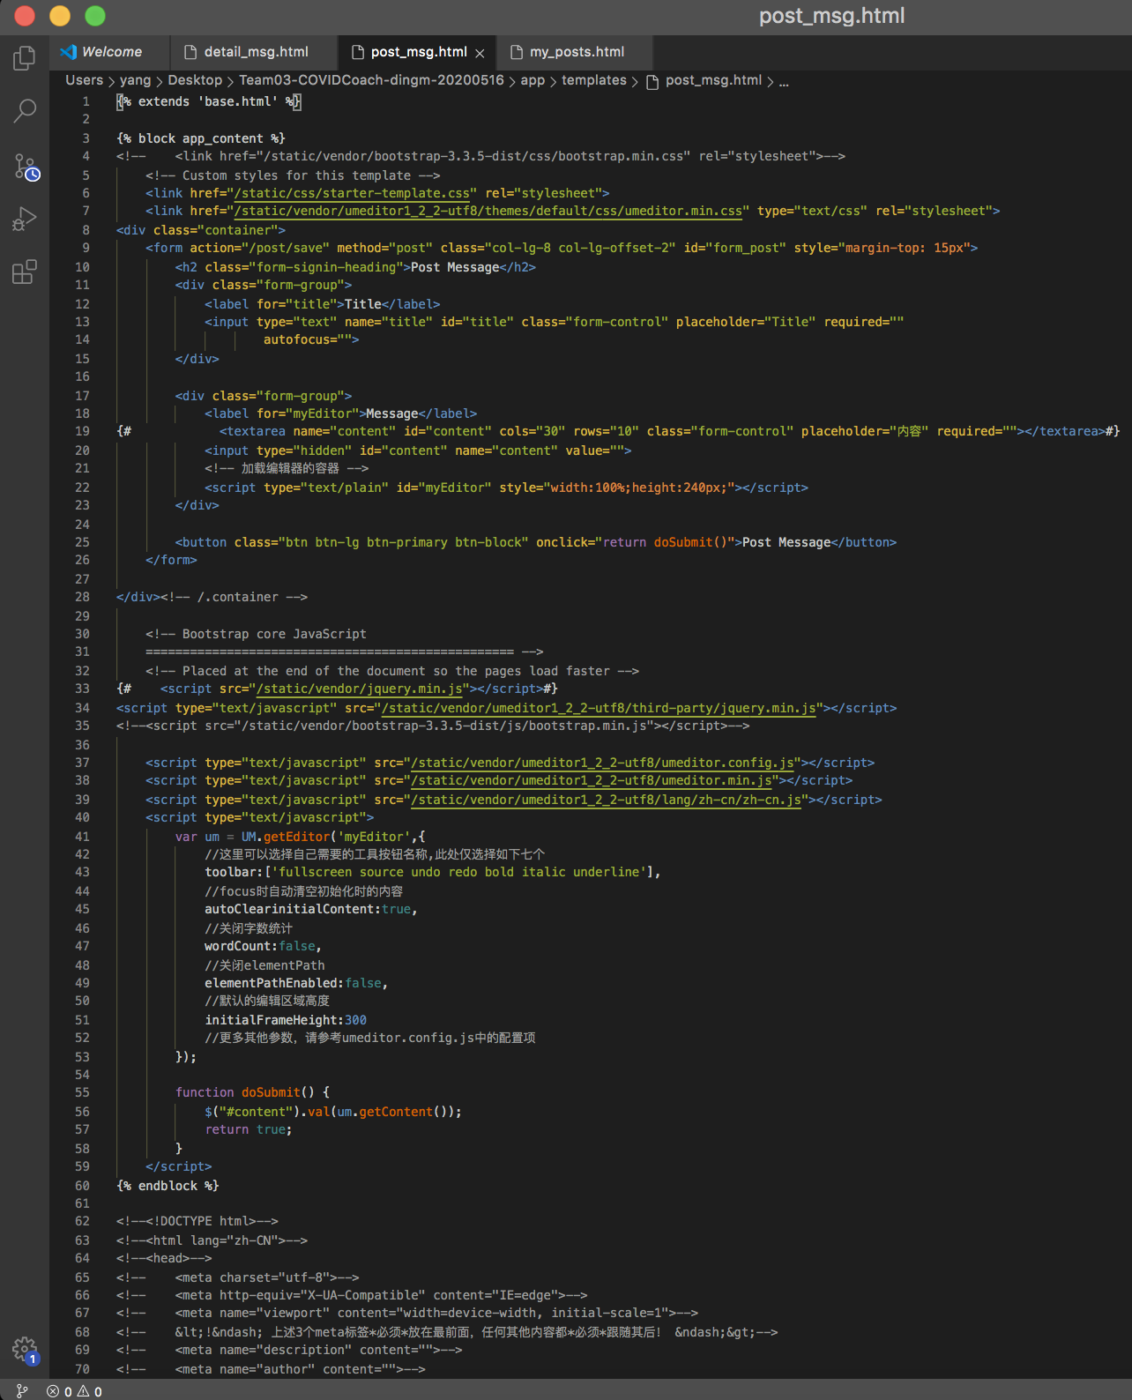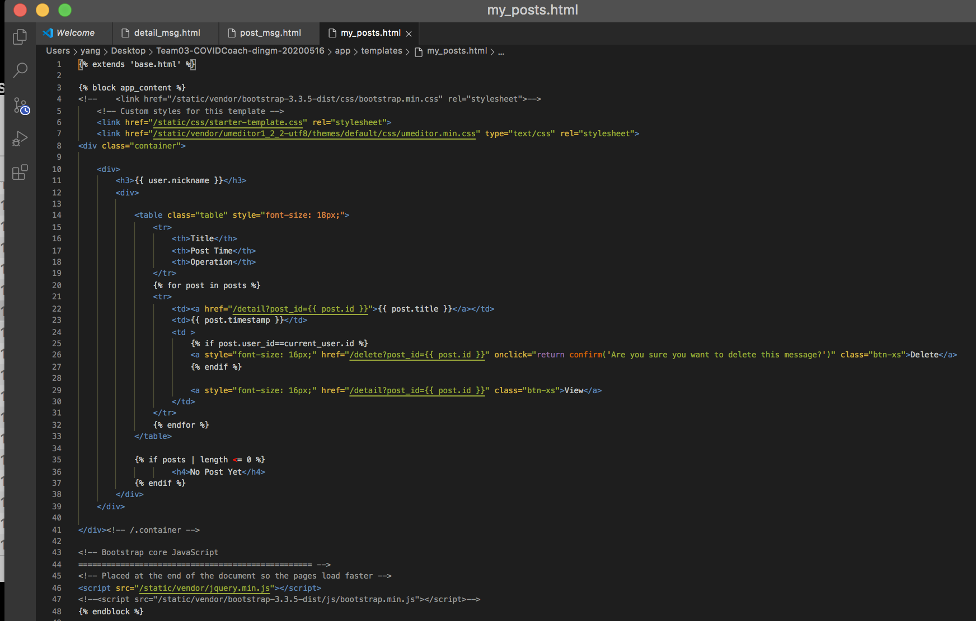
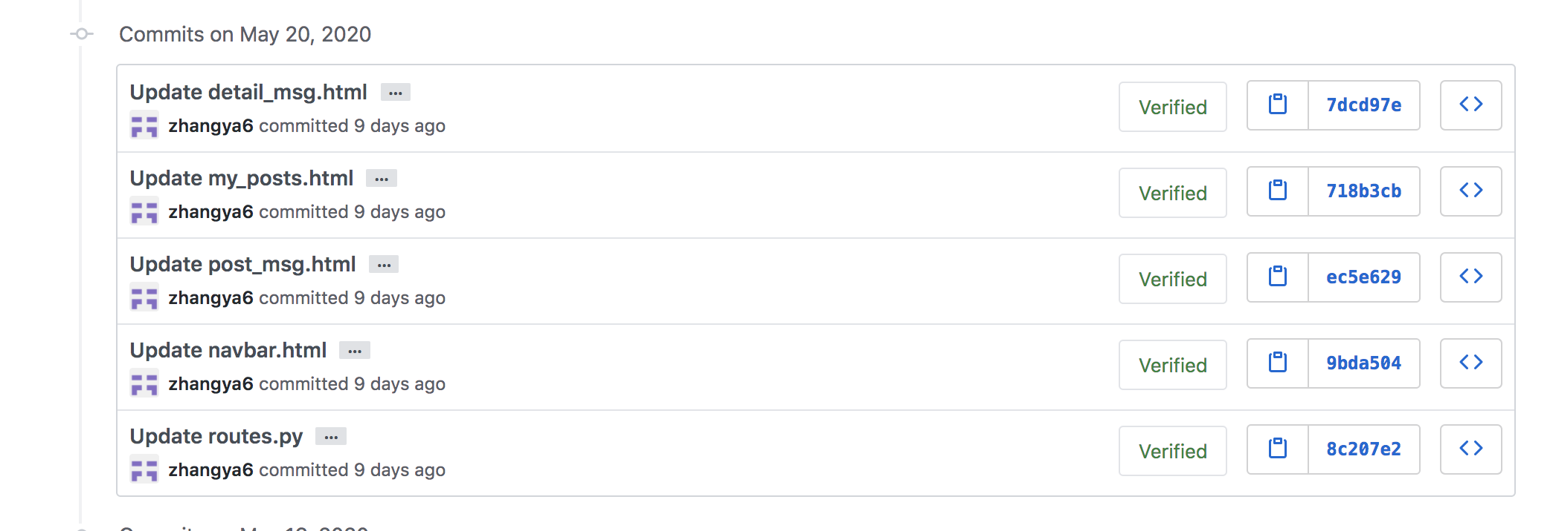

User Story 2 (30pts)
What is the other user story you worked on during the Sprint?
Get talk : As a User I want to go to the forum page and see a beautiful board page (create forum page basic skeleton and styling the page)

What is the status of the user story?
Done

Provide evidence (e.g., screenshots, URLs, etc.) showing your contributions to the completion of the first user story you worked on during the Sprint. If your grader is not convinced, you will lose points.
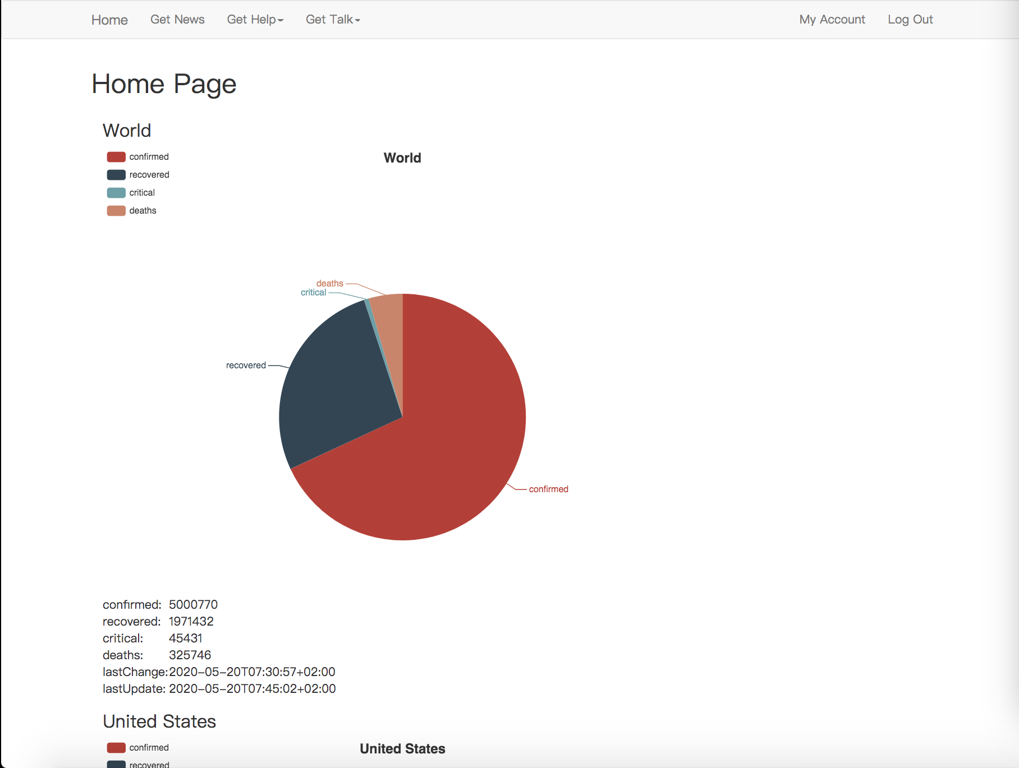
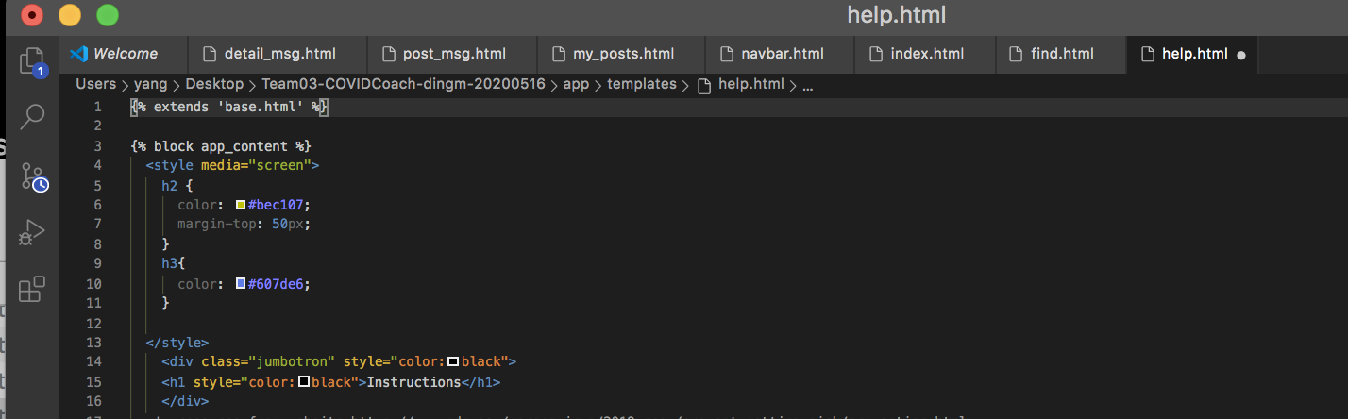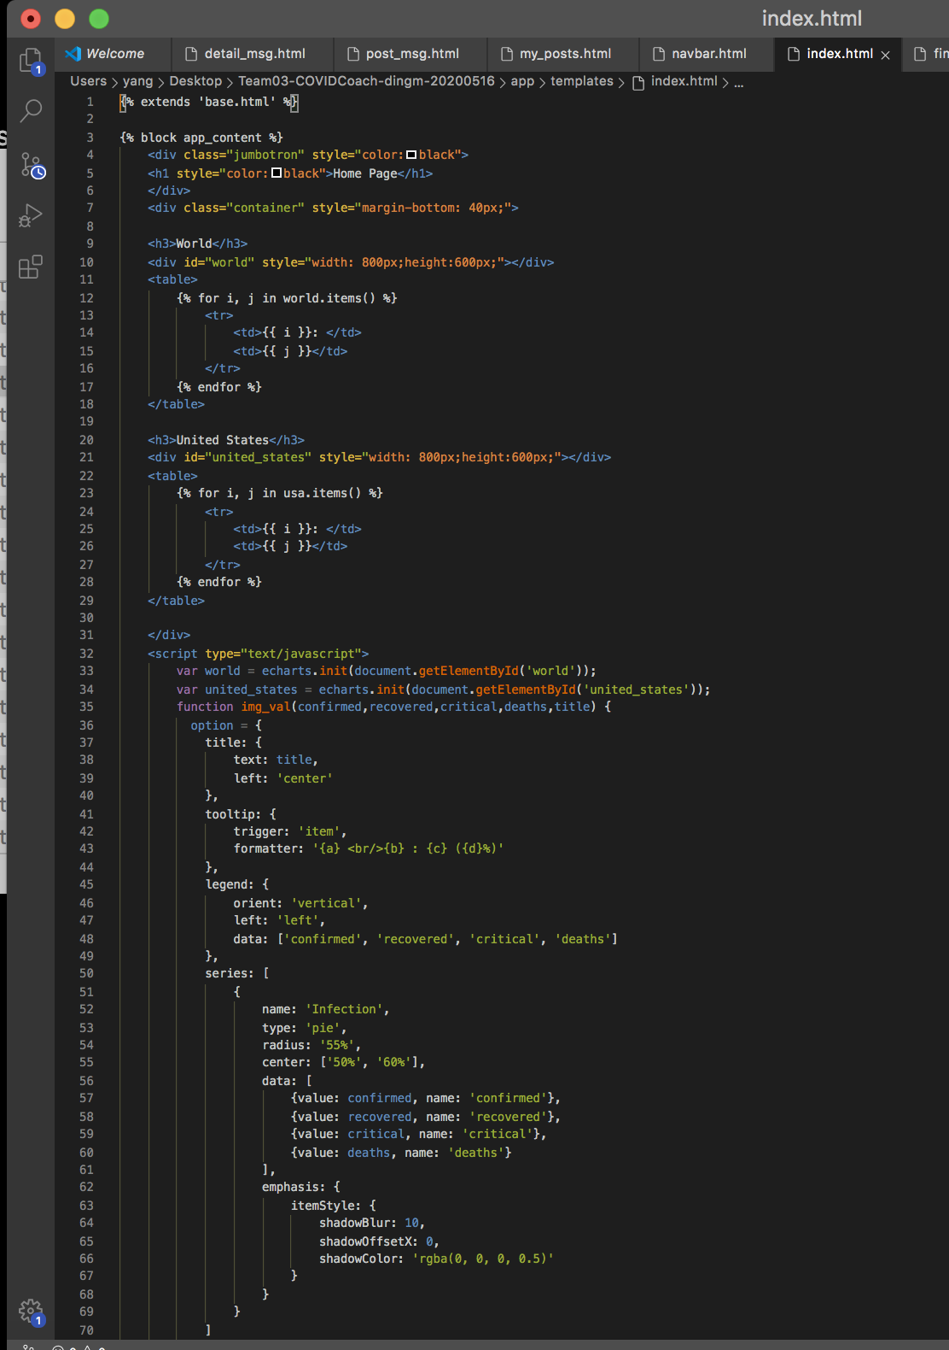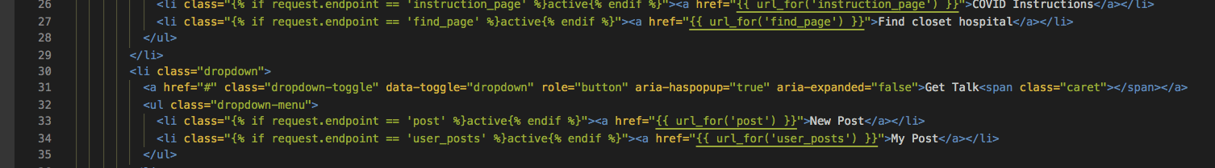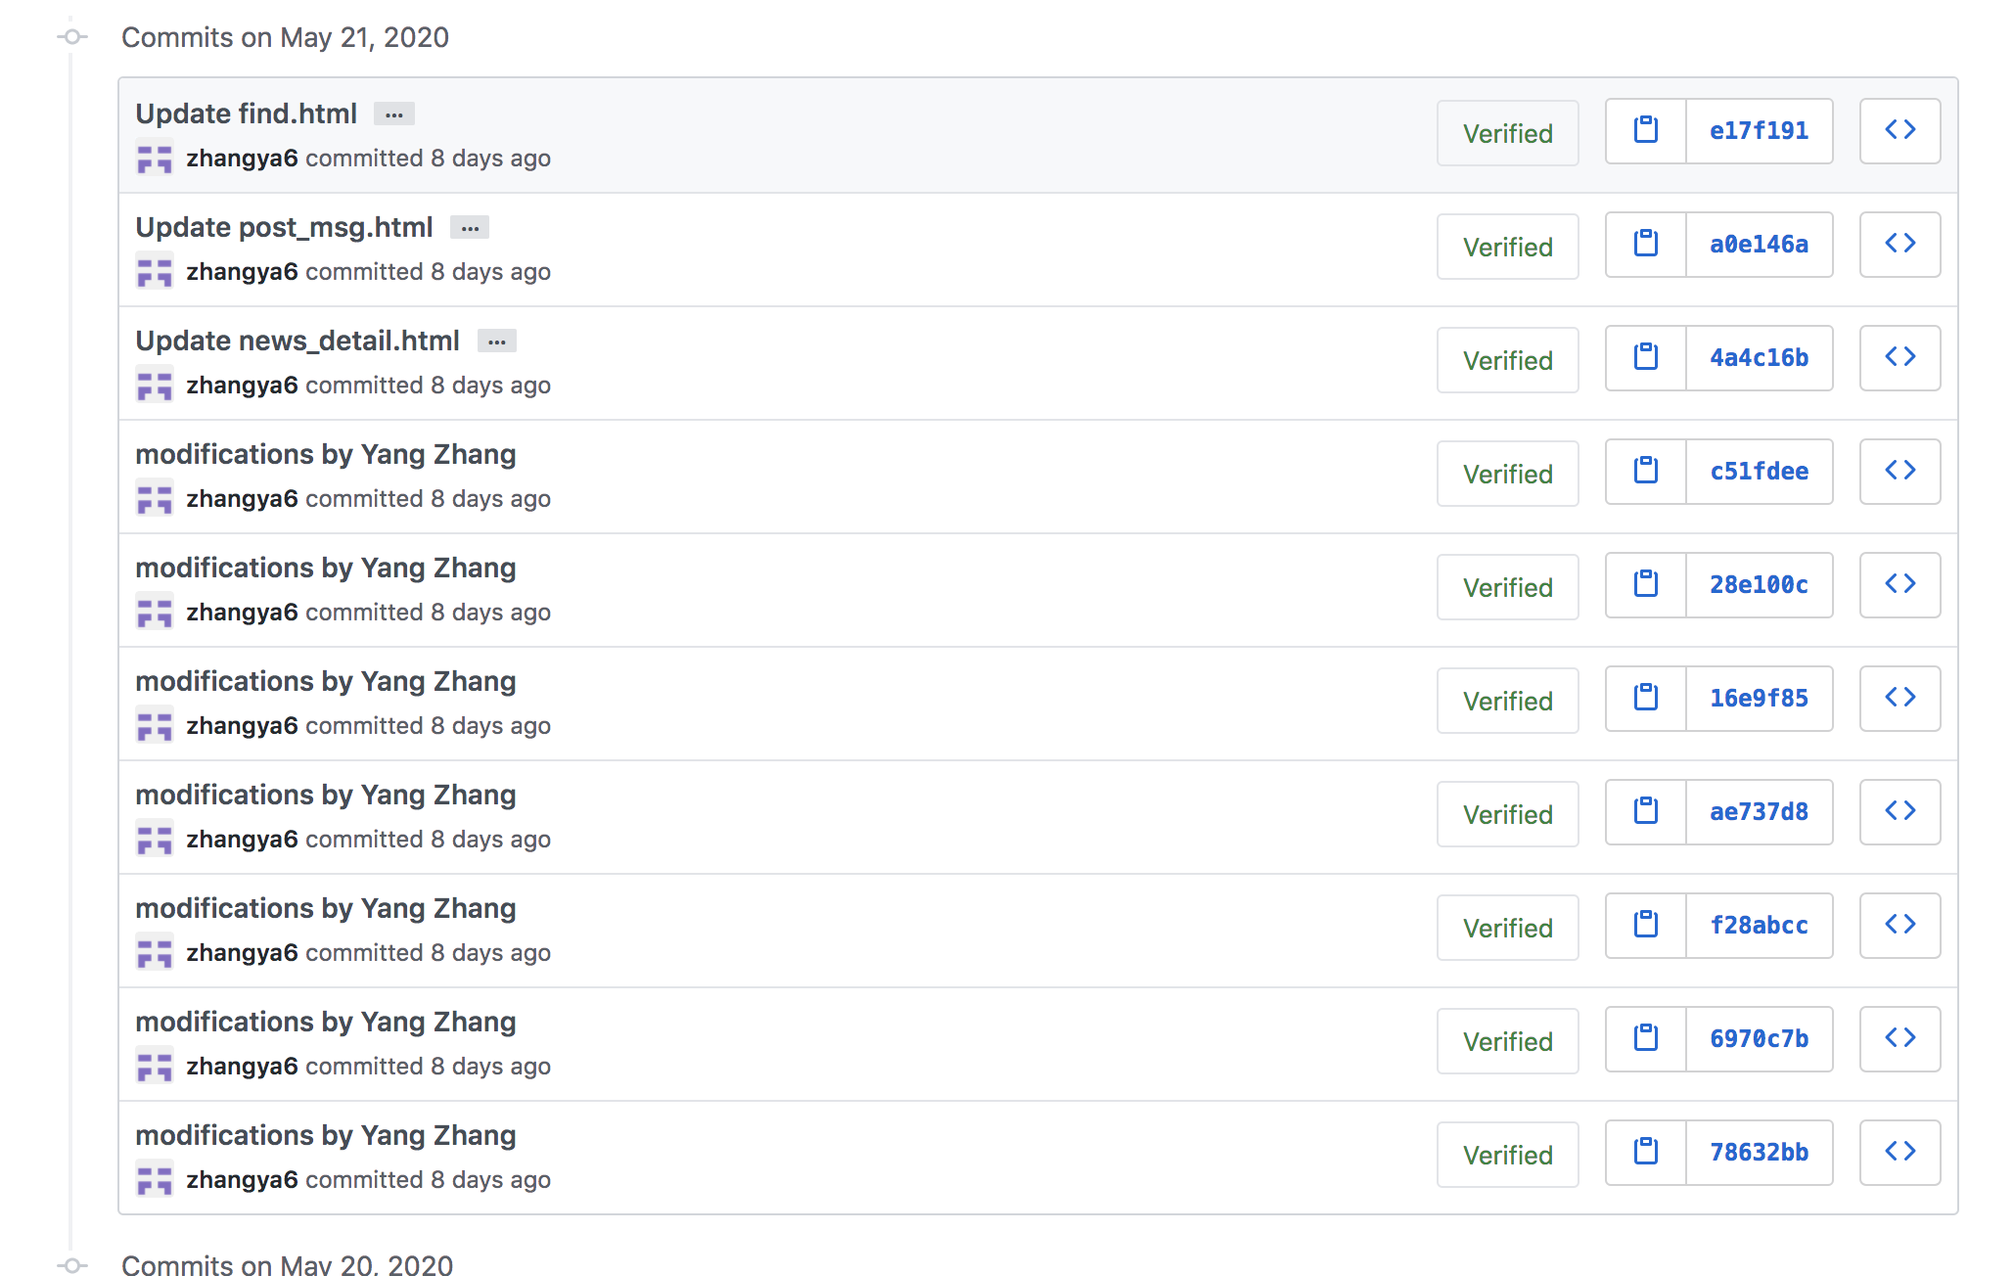
I have unified the color, font, size and width of the navigation bar of all interfaces to make them as a whole. I enlarged the icon on the front page. I put the mypost and post interface into gettalk. It also fixed the size of all news pictures in getnew. Finally, the font and color are unified.

Stand-Up Reports (10pts)
Provide screenshots of your 4 stand-up reports (two from Week 8, two from Week 9)---all reports must answer all 3 questions and you must show that they happened on 4 different days. Stand-up reports are not required for weeks you were the Scrum Master.
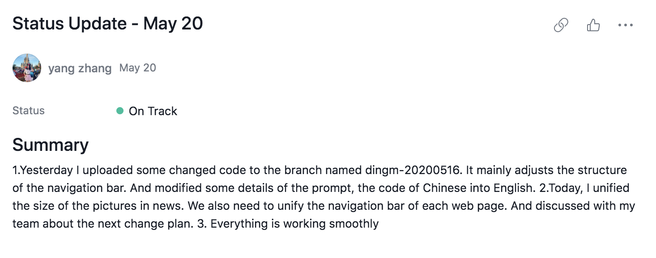

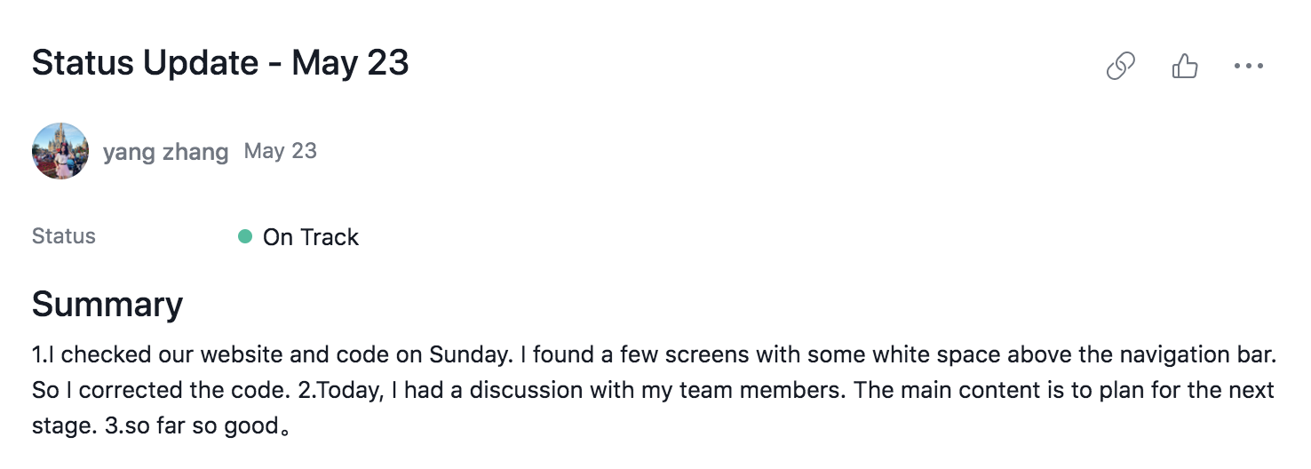

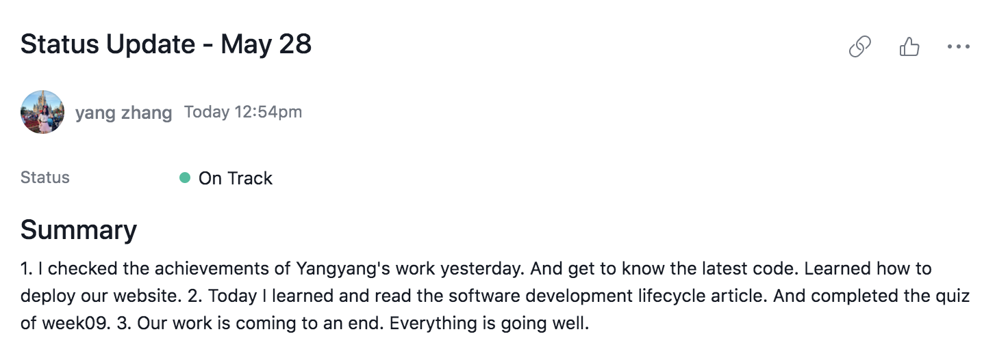

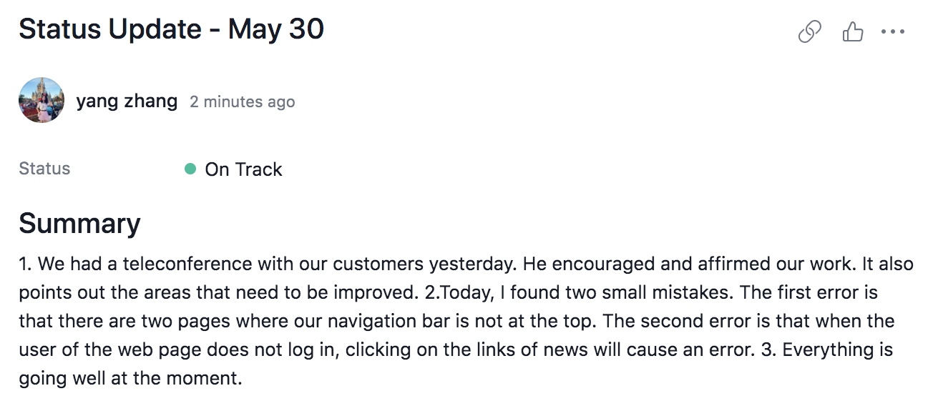

SDLC (40pts)
Instructions
- After going through this week’s readings, think about when you might use each software process model. Then, answer the questions below about several software process models.
- To avoid losing points, follow all the instructions and don’t be vague.

Waterfall Model (10pts)
Describe (in a sentence) a project that could be well-suited to this software process model.
When the customer demand is stable and the work can be done in a linear way, the waterfall model is easy to use and effective.

What are two (or more) reasons this software process model would be a reasonable choice?
- The waterfall model provides checkpoints by phase for the project. After the current stage is completed, we only need to focus on the following stages.
- Waterfall model can be used in an iterative model. Incremental iteration is applied to the waterfall model. Each iteration produces a runnable version and adds more functionality. Each iteration must be tested for quality and integration.

What is one (or more) reason this software process model might NOT be a reasonable choice?
- Waterfall models have little feedback between phases of a project. And the results can only be seen later in the project lifecycle.
- The waterfall model needs to track various project phases with too many mandatory completion dates and milestones.

Spiral Model (10pts)
Describe (in a sentence) a project that could be well-suited to this software process model.
For large-scale software projects, when the requirements are not clear, it is suitable to develop with a spiral model, which is convenient for risk control and requirement change.

What are two (or more) reasons this software process model would be a reasonable choice?
- The spiral model is flexible in design and can be changed at all stages of the project. It builds large systems in small segments, making cost calculation easy.
- In this model, customers always participate in the development of each stage, which ensures that the project does not deviate from the right direction and the controllability of the project. The customer keeps up-to-date with the project so that he or she can interact effectively with management.

What is one (or more) reason this software process model might NOT be a reasonable choice?
- The spiral model needs a lot of experience and expertise in risk assessment. In the development of projects with high risk, if the risk can not be identified in time, it will cause great losses.
- And too many iterations will increase the development cost and delay the submission time.

V-Model (10pts)
Describe (in a sentence) a project that could be well-suited to this software process model.
V-model is generally applicable to the development of some traditional information system applications, such as small projects, small-scale companies, and projects with stable business requirements.

What are two (or more) reasons this software process model would be a reasonable choice?
- V-model can effectively shorten the development cycle and reduce the development cost.
- V-model can also effectively improve the development efficiency and speed up the development process.

What is one (or more) reason this software process model might NOT be a reasonable choice?
- V-model is easy to be misunderstood as a stage after development. Because of its order, when the code is finished and formally enters the test, some bugs found at this time may not be easy to find the root cause, and it is difficult to modify the Dao code.
- In practice, the rework of the V-model is very large. Due to the large change of requirements, requirements, design and test need to be changed repeatedly.

Big Bang Model (10pts)
Describe (in a sentence) a project that could be well-suited to this software process model.
For small projects with very small development teams, the big bang model will be followed.

What are two (or more) reasons this software process model would be a reasonable choice?
- The big bang model is very simple, almost no need to plan a model.
- The big bang model is easy to manage without formal procedures.
- It also provides developers with flexibility, which is a good learning aid for new comers or students.

What is one (or more) reason this software process model might NOT be a reasonable choice?
- The big bang model has high risk and uncertainty.
- The big bang model is not applicable to complex and object-oriented projects and long-term and ongoing projects. If the client requirements are misunderstood by the developers, it will cause a lot of extra money and time loss.

Course Feedback (Optional)
If you would like to and have time, please let me know how the course is going for you by completing this short questionnaire: https://oregonstate.qualtrics.com/jfe/form/SV_cOKRKQc1E70l4EJ
The questionnaire is anonymous, but there’s a field at the end where you can type in your name if you would like me to know it was you who left the feedback.

Interview Feedback (Optional)
Do you have any feedback you would like me to anonymously pass on to Hannah Pruse?
Feedback

Future Interviews (Optional)
Are you a current or soon-to-be software professional? If so, would you be interested in being an interviewee for this course during future terms? There are no benefits to volunteering except that you’ll potentially have a positive impact on other people and help them prepare for being software professionals. If you might be interested, please let me know how/when I can contact you. Thank you!
ContactInfo

