Time Report
We were assigned our project starting October 1st to October 25th. Our project, Three Band Audio Visualizer’s purpose is to take in a frequency signal, transfer it to a voltage source and display the strength of the signal in the LEDs. The group met once a week for about three hours each time. We thought this was sufficient time to see what each member was doing. Everyone was assigned a part of the project to focus on, based off of familiarity. When a team member was stuck outside the meeting time, we would talk after class to see if we could help. Overall, we had a total of 12 hours of meeting time, and one hour-two hours daily on our own.

Schematics/Drawings
Pin Layout
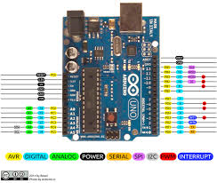

Block Diagram
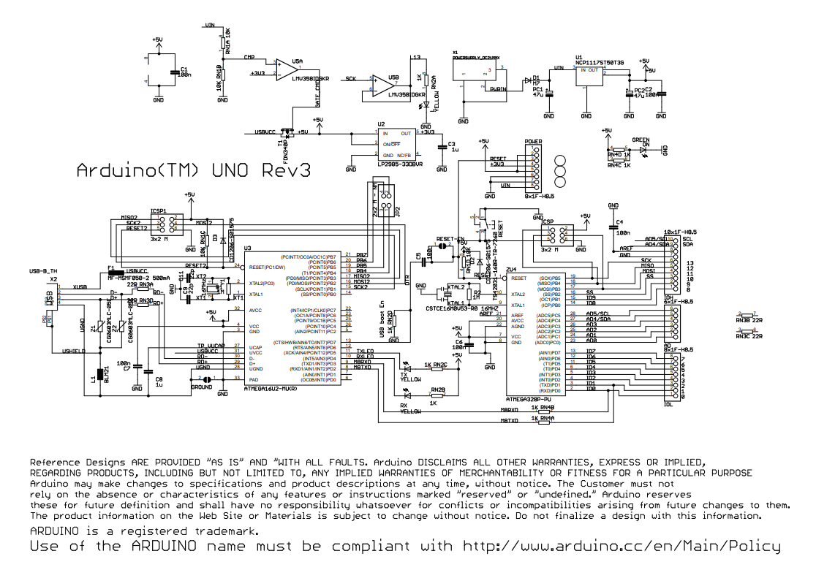

Second draft
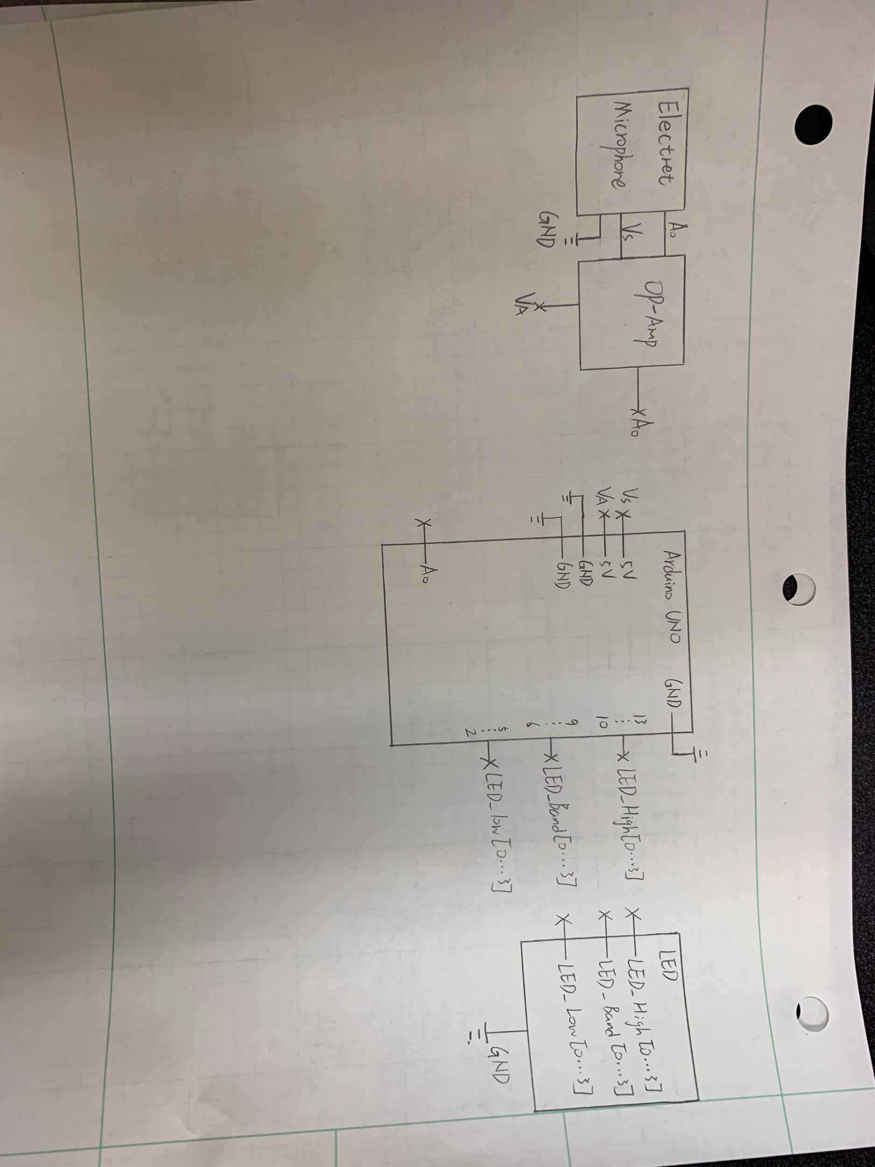

Completed Build

