Kiernan & Co.

Longboard Speedometer

User’s Manual



Read this manual before operating the Longboard Speedometer

Keep this manual for future reference

Always use safety equipment when riding a longboard

Introduction:

Thank you valued customer for your purchase of the Longboard Speedometer! This user’s manual will cover the features, specifications, operation, and troubleshooting of your brand new Longboard. Our customer service hotline can be reached Mon-Fri from 9AM-5PM at 1-800-555-1802.

How to Operate:

Your longboard speedometer comes pre-assembled for your ease of use. Just place your fully charged Lithium-Ion batteries in their battery pack on the bottom of the board to begin. Now your longboard speedometer and odometer are now on and should be displayed on the screen. (If screen is blank and/or the longboard speedometer is not functioning as desired, please see the “Troubleshooting” section below) Congratulations, you may now enjoy your new board and ride it like any other longboard. To reset your odometer press the red button next to the display and quick-read LEDs.

\*\*Always wear proper safety equipment when riding\*\*

Features:

* Six quick-read LEDs
* Speedometer
* Resettable Odometer
* Long Battery Life
* Small size
* Powered by 1 rechargeable Lithium-Ion cells
* Rated for 30mph max speed

Specifications:

Dimensions:

Top board: 2.09 inches x 1.25 inches

Bottom board: 2.69 inches x 2.65 inches

Power Usage:

Maximum Current Draw: ~170mA Max

Battery Life: ~17 hours

System Diagram:

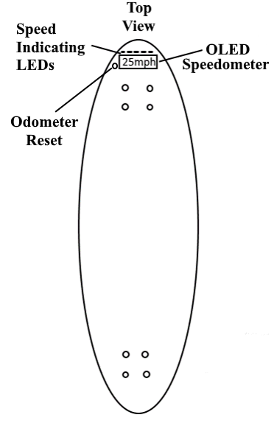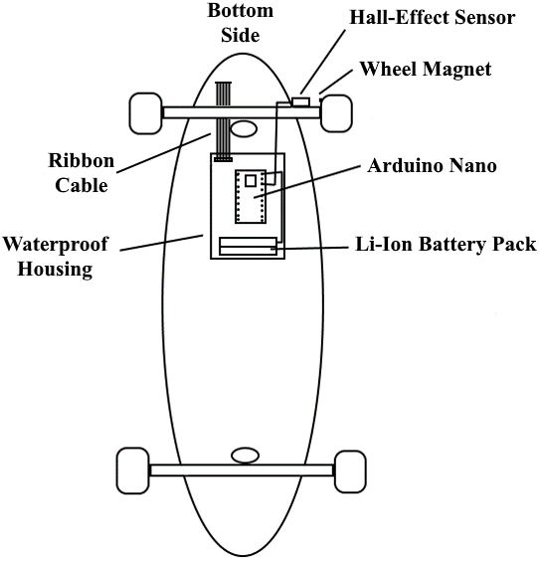

Top Board Schematic & PCB:

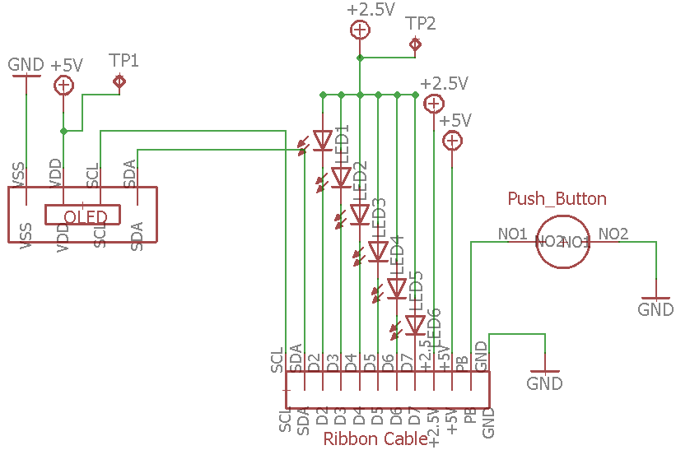

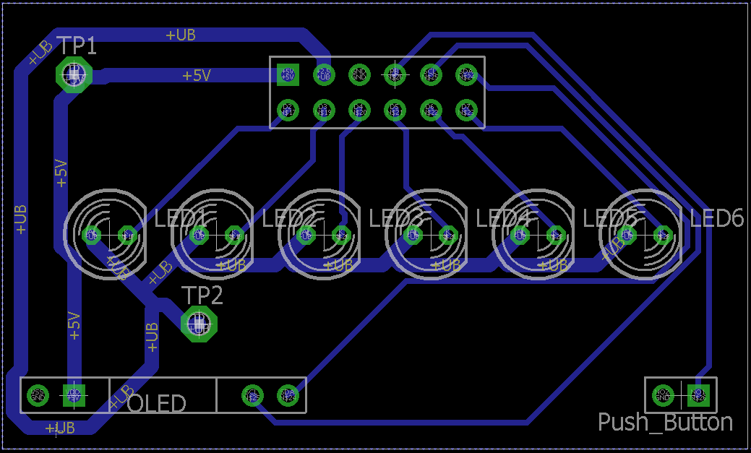

The images above are of the electrical schematic and PCB (printed circuit board) layout for the top board of the speedometer kit. This board and components will be located on the top of the longboard deck in front of the rider’s front foot. The top board contains the 6 speed read LEDs along with the OLED display, odometer reset button, and ribbon cable connector. Two test points are also included for troubleshooting. As you can see in the electrical schematic above, all LEDs are connected via a common anode to +2.5v. The supply voltage can be checked with a digital multimeter using the test point TP2. TP2 can be found in the PCB layout and by placing one multimeter probe on the test point and one on the GND or ground pin you can verify the +2.5v supply line. The +5v supply line which feeds the OLED display can also be checked by using a multimeter probe on the TP1 test point seen above. Test point analyzing may prove to be important for verifying the proper attachment of the ribbon cable. The push button in the bottom right works by pulling a signal from the Arduino to ground. There is no need to worry about a missing second trace because the whole copper plane of the board is grounded.

Bottom Board Schematic & PCB

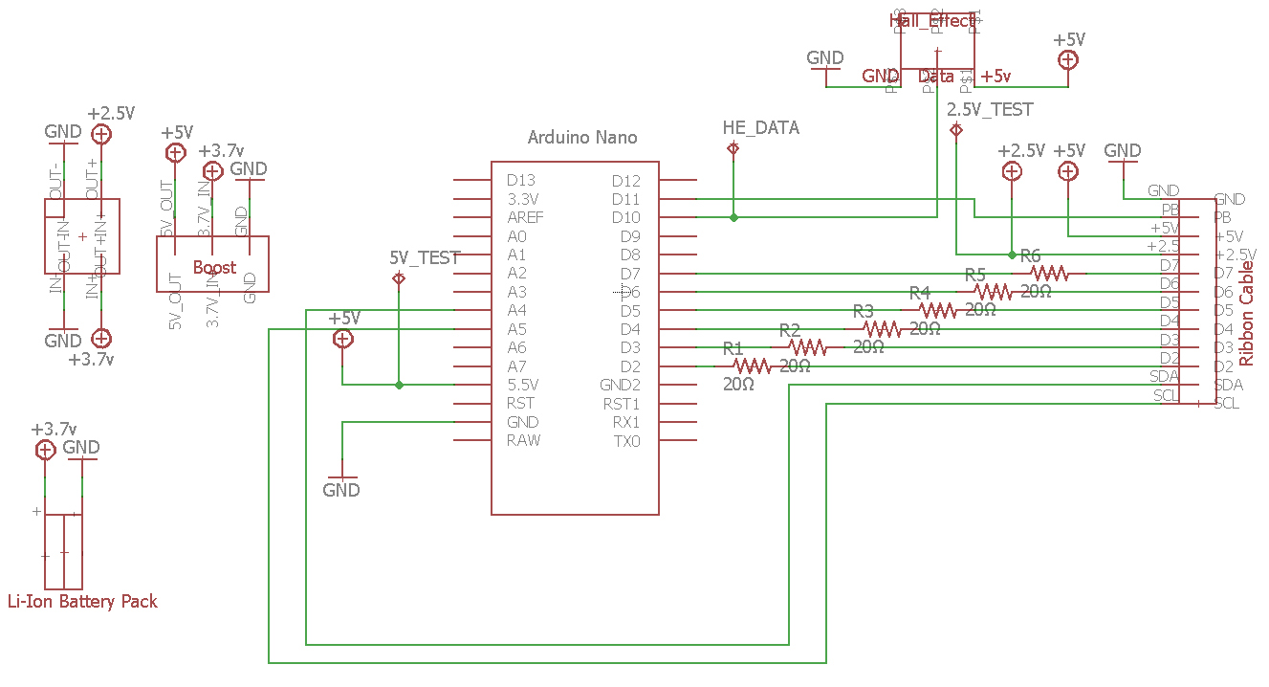

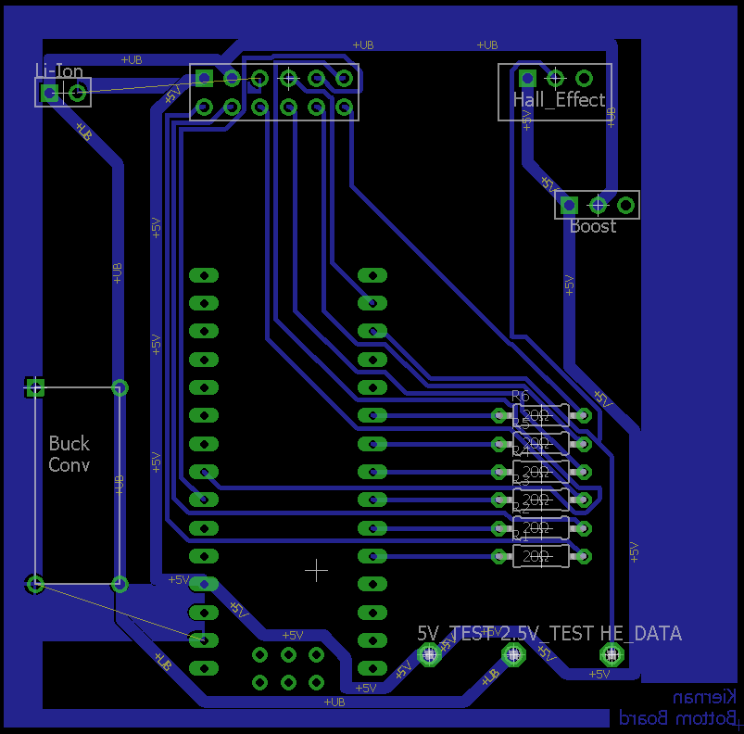

Featured above is the electrical schematic and PCB layout of the bottom board. This board will be located underneath the deck of the longboard inside a waterproof case. Similarly to the top board, the bottom board has two test points for both the +2.5v and +5v supply lines. The testing methods are the same as described in the previous section. Unlike the top board, the bottom board has a test point for the data coming from the Hall Effect sensor. To properly analyze this test point an oscilloscope must be used. With the correct time and voltage scales on the oscilloscope the data from the Hall Effect sensor can be properly viewed. Below is a sample waveform from a Hall Effect sensor.

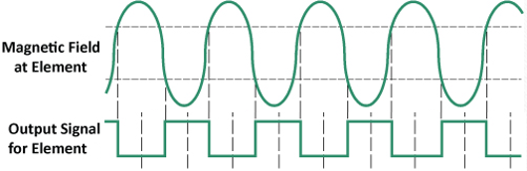

In the graphic above we see that when the magnetic field reaches a certain strength the output of the Hall Effect sensor is pulled low. This means when the magnet on the wheel is not near the Hall Effect sensor, the test point should be showing a constant +5v signal. However, when the magnet is next to or passes by the sensor, the +5v signal should be brought to roughly 0v. Going back to the circuit above, the device used to control all sensors and displays is the Arduino Nano microcontroller which can be found in the middle of the board. Next to the Arduino there are two separate devices soldered directly to the breadboard (besides the six current limiting resistors). The first is the buck converter. The buck converter is located to the left of the Arduino and it takes the +3.7v from the Lithium Ion battery and brings it down to the +2.5v that is used to power the LEDs. Next, to the right of the Arduino is the boost converter. Unlike the buck converter, the boost converter increases the +3.7v to +5v which it uses to then power the Arduino. Just above the Arduino, the ribbon cable connector can be found. This links power and data between the top and bottom boards. To the left of the connector is where the Lithium Ion battery pack is connected. This battery pack is used to power the Arduino as well as all the external displays and sensors. Without a battery connected the circuit will not function. Finally in the top right the power, ground, and data connectors for the Hall Effect sensor are located. Without these lines connected the speed of the board cannot be determined.

Troubleshooting:

Speedometer displaying incorrect speed:

Check the inside of the front right wheel to make sure magnet is still attached. If the magnet has become detached you can easily re-attach it to the same location using hot-glue or super-glue. If the magnet is not the issue, confirm that all wires are intact and connected and that the Arduino light is green. If a wire is broken or the Arduino microcontroller is dead please contact our hardware support team at 1-800-555-5203. If you have recently replaced the wheels on your longboard, confirm they are 70mm. The speedometer is set to work only with 70mm wheels and anything else will return an incorrect speed value.

Screen is blank:

Confirm batteries are charged. Check Arduino microcontroller to make sure it’s green light is on. Make sure no have become disconnected or broken. Using a multimeter confirm an output of 5v on the top-board test point located next to the OLED display.

Software:

In this section a few integral pieces of code are displayed. In the first set of code the speed measurements can be found. Simply put, this code derives the mph value by comparing the time between two passes of the magnet by the Hall Effect sensor. This time difference is then converter to revolutions per minute and is finally re-converted into ‘miles per hour’. This ‘miles per hour’ value is based on a longboard with 70mm wheels.

